1. Install Haproxy

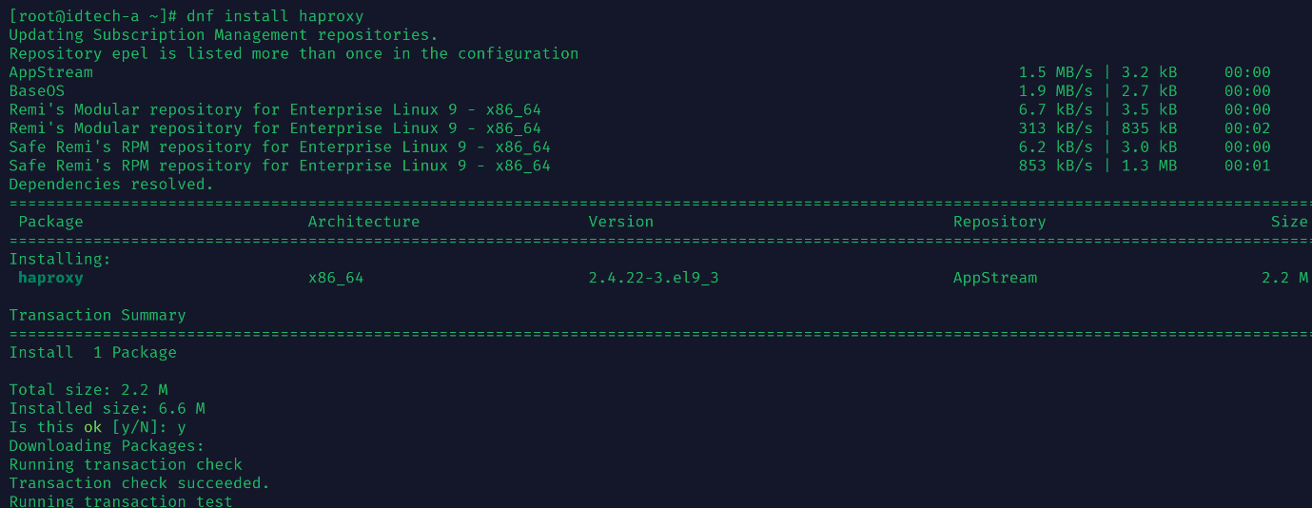

2. Configure 2 frontends and 2 backends

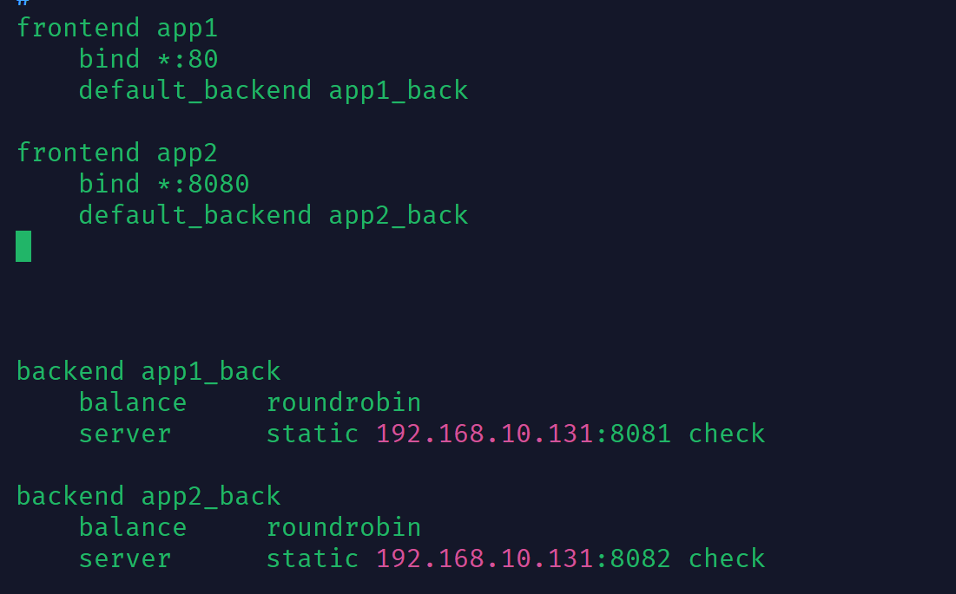

frontend app1

bind *:80

default_backend app1_back

frontend app2

bind *:8080

default_backend app2_back

backend app1_back

balance roundrobin

server static 192.168.10.131:8081 check

backend app2_back

balance roundrobin

server static 192.168.10.131:8082 check



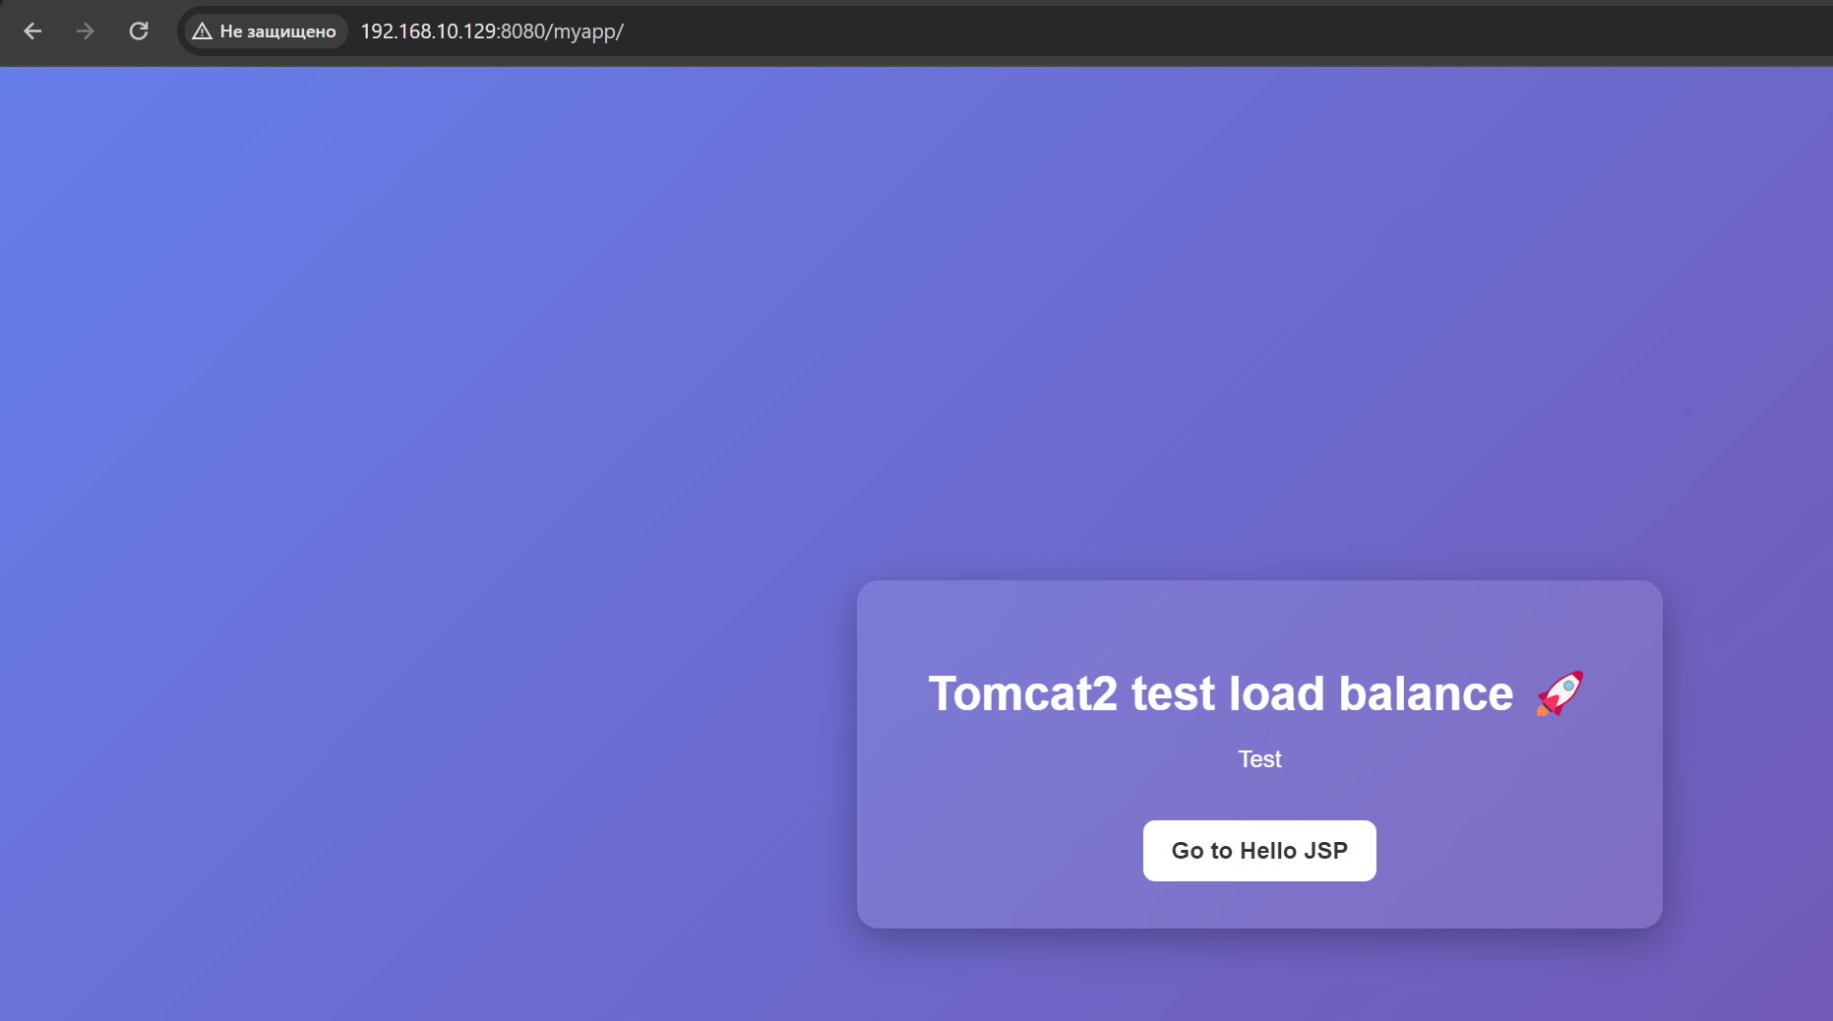

3. Install socat

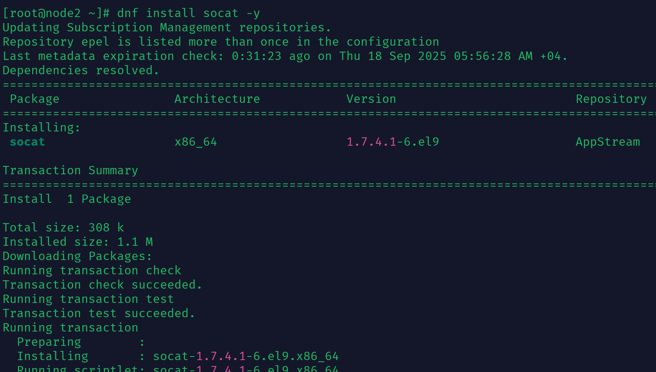

listen stats

bind *:8081

stats enable

stats hide-version

stats show-node

stats uri /haproxy-stats

# stats auth username:parol

stats refresh 20s

3.1 use this command and send screen echo "show info"|socat stdio /var/lib/haproxy/stats

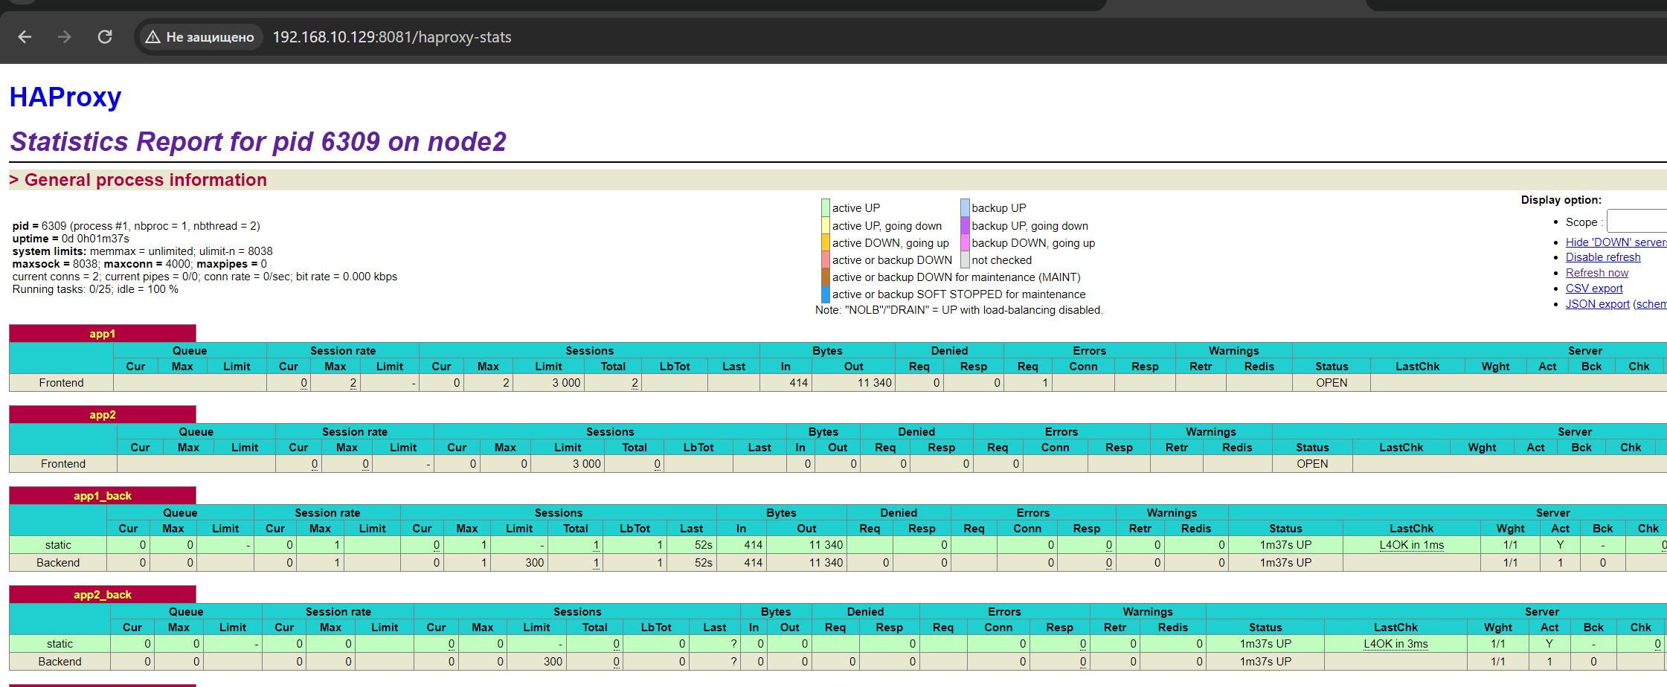

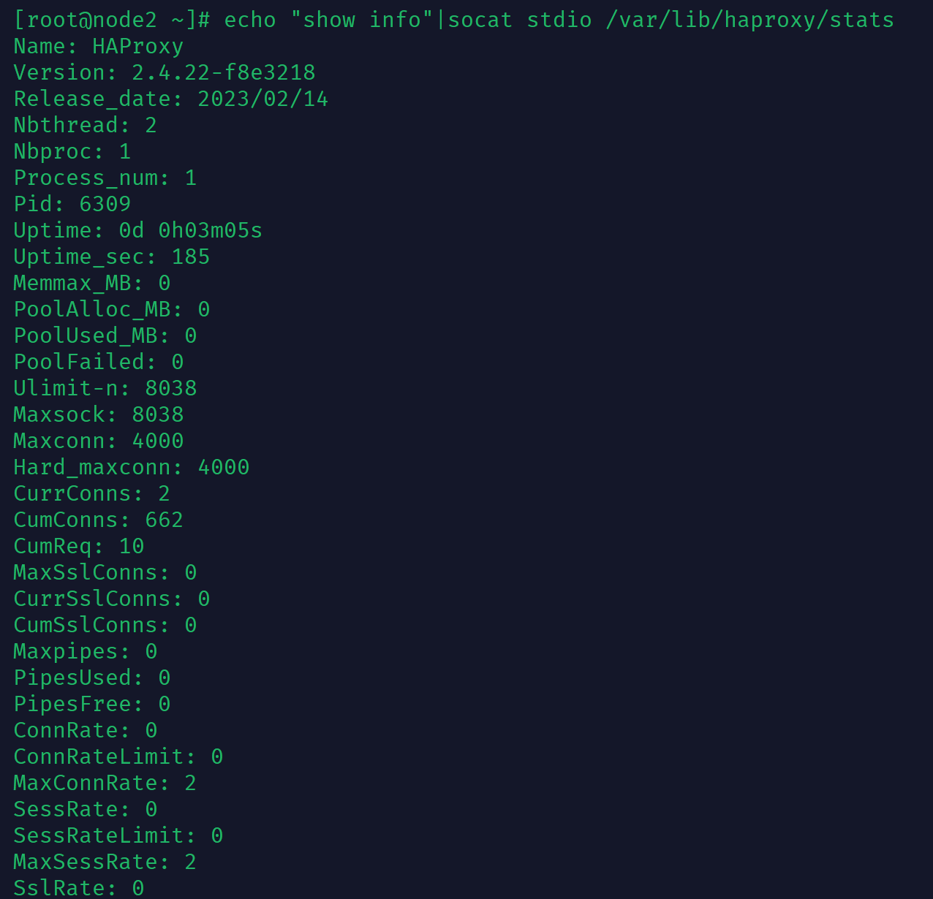

4. Sign 2 server certificate “firsthaproxy.az” “secondhaproxy.az” and 2 client certificate

“hapclient1” and “hapclient2” . Send certificates screen on windows

SERVER:

openssl.cnf edit: for firsthaproxy:

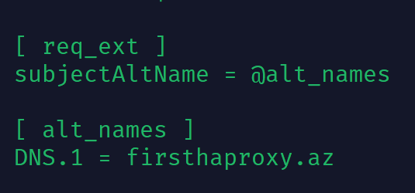

openssl genrsa -aes256 -out private/private-firsthaproxy.key 2046

openssl genrsa -aes256 -out private/private-secondhaproxy.key 2046

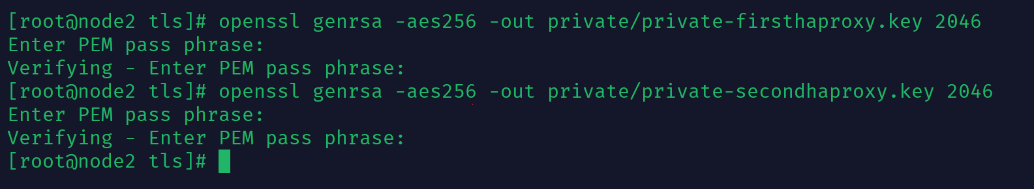

openssl req -config openssl.cnf -new -sha256 -key private/private-firsthaproxy.key -out csr/firsthaproxy.csr.pem

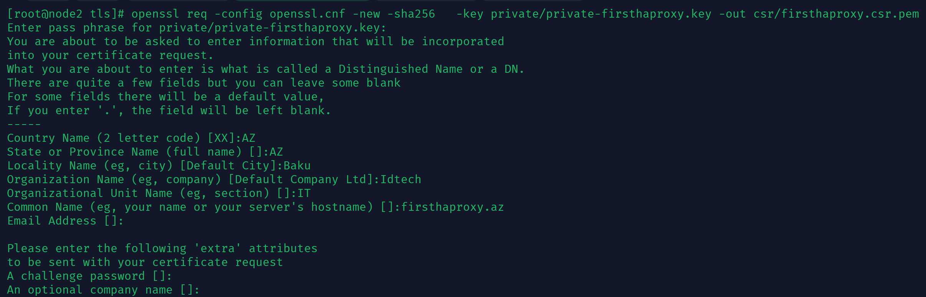

openssl req -in csr/firsthaproxy.csr.pem -text -noout

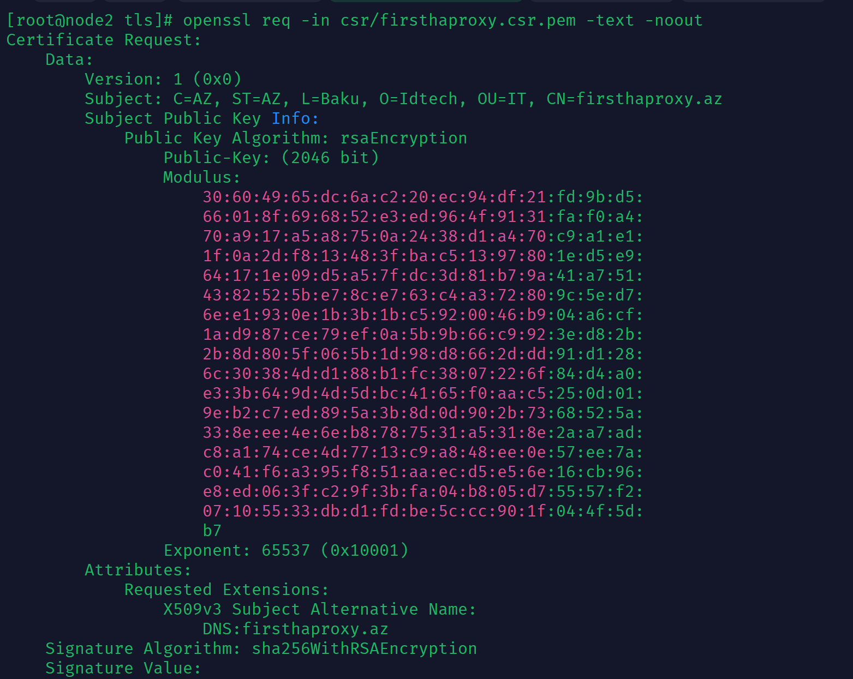

Edit openssl.cnf: for secondhaproxy

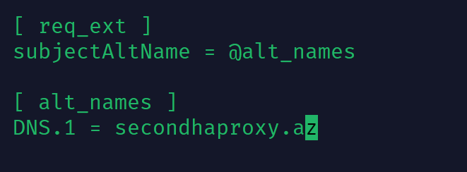

openssl req -config openssl.cnf -new -sha256 -key private/private-secondhaproxy.key -out csr/secondhaproxy.csr.pem

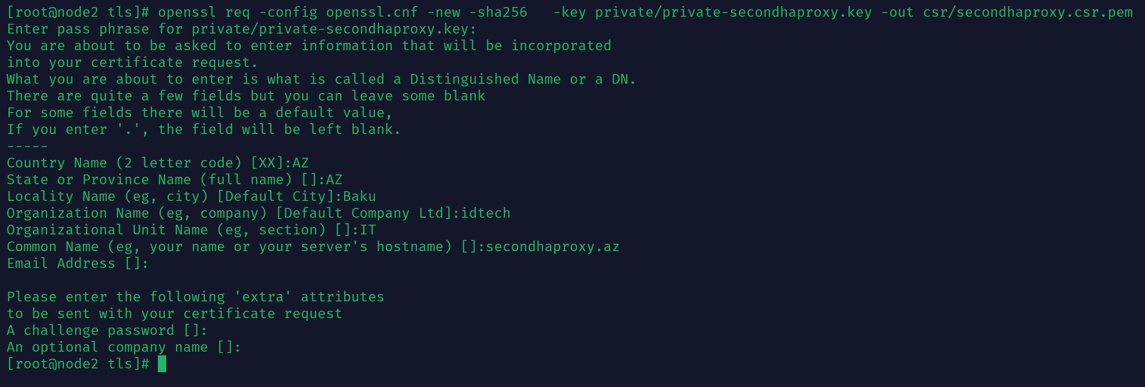

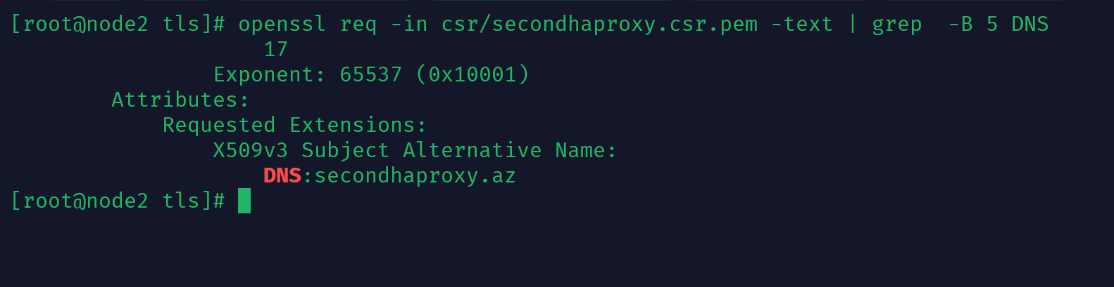

[root@node2 csr]# scp firsthaproxy.csr.pem secondhaproxy.csr.pem root@192.168.10.128:/CA_SERVER/intermediate/csr

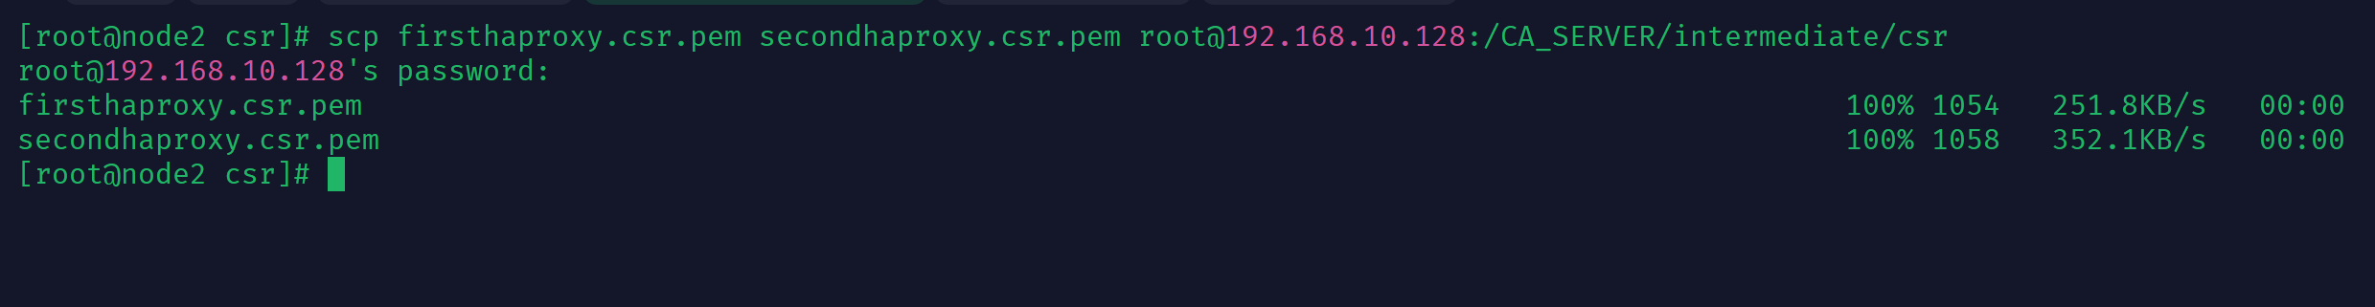

openssl ca -config openssl.cnf -extensions server_cert -md sha256 -notext -in csr/firsthaproxy.csr.pem -out certs/firsthaproxy.crt.pem

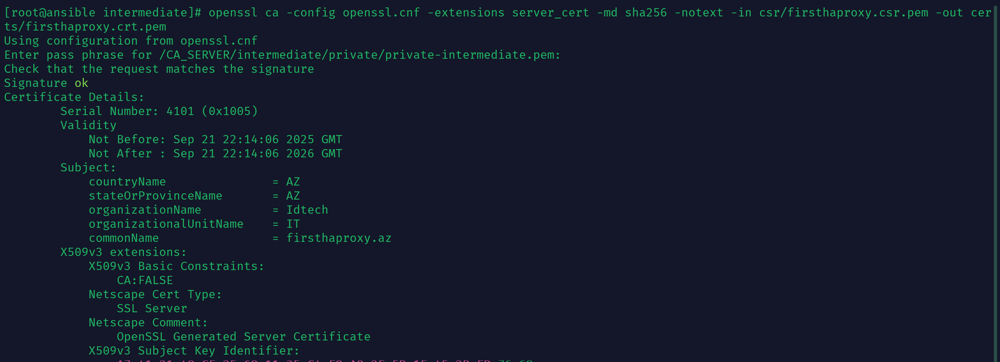

openssl ca -config openssl.cnf -extensions server_cert -md sha256 -notext -in csr/secondhaproxy.csr.pem -out certs/secondhaproxy.crt.pem

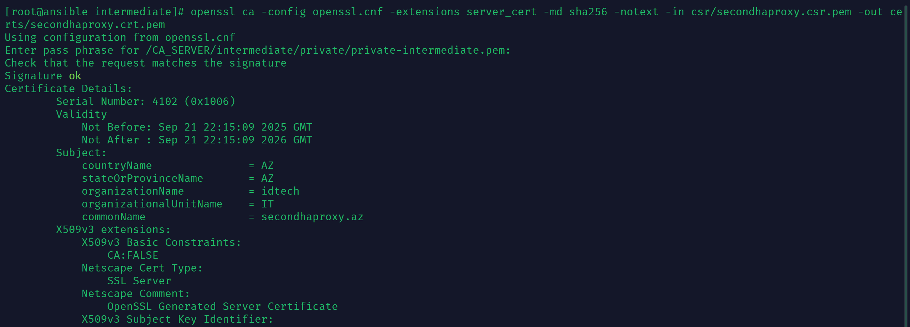

scp firsthaproxy.crt.pem secondhaproxy.crt.pem root@192.168.10.129:/etc/pki/tls/certs



CLIENT:

openssl genrsa -aes256 -out private/private-haclient1.key 2048

openssl genrsa -aes256 -out private/private-haclient2.key 2048

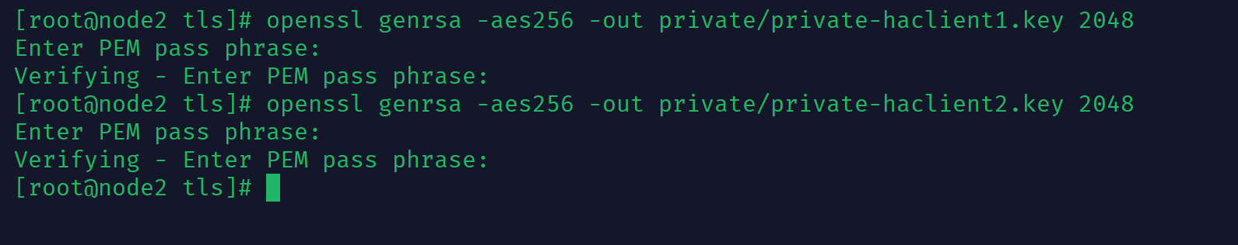

Edit openssl.cnf: for haclient1

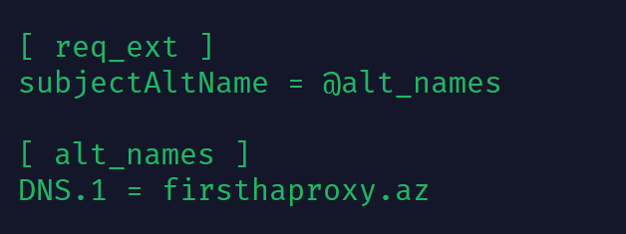

openssl req -config openssl.cnf -new -sha256 -key private/private-haclient1.key -out csr/haclient1.csr.pem

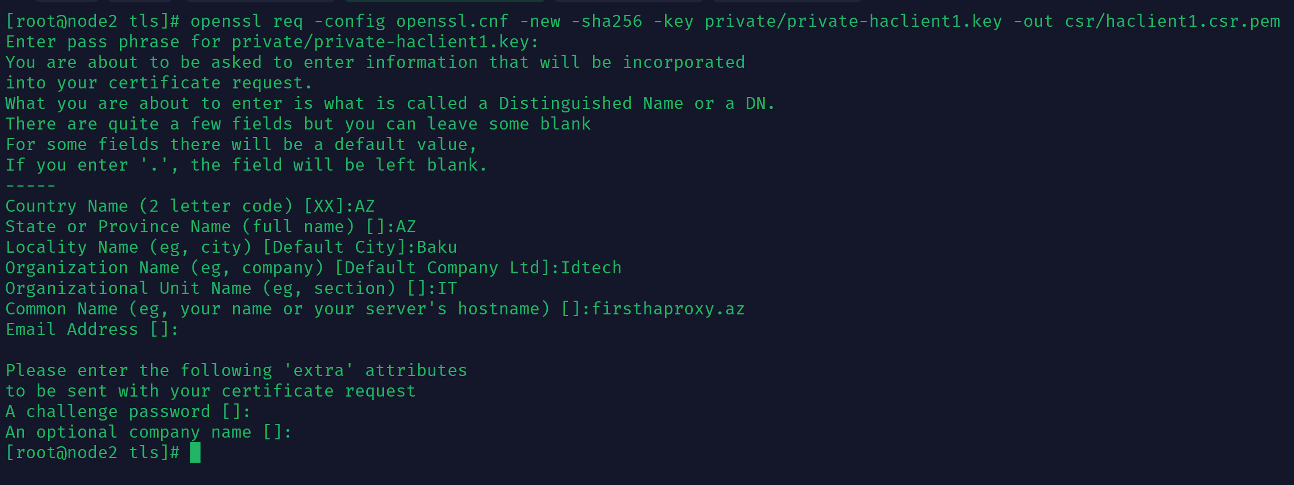

Edit openss.cnf: for haclient2

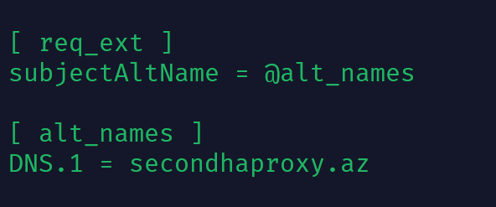

openssl req -config openssl.cnf -new -sha256 -key private/private-haclient2.key -out csr/haclient2.csr.pem

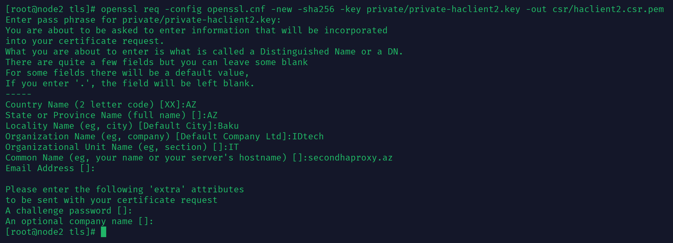

scp csr/haclient* root@192.168.10.128:/CA_SERVER/intermediate/csr

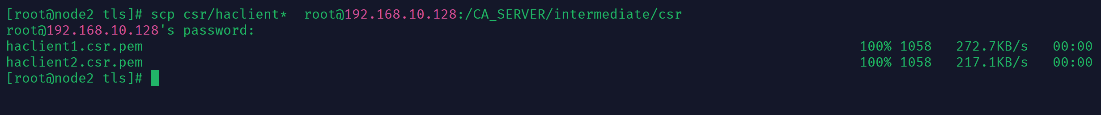

openssl ca -config openssl.cnf -extensions usr_cert -md sha256 -notext -in csr/haclient1.csr.pem -out certs/haclient1.cert.pem

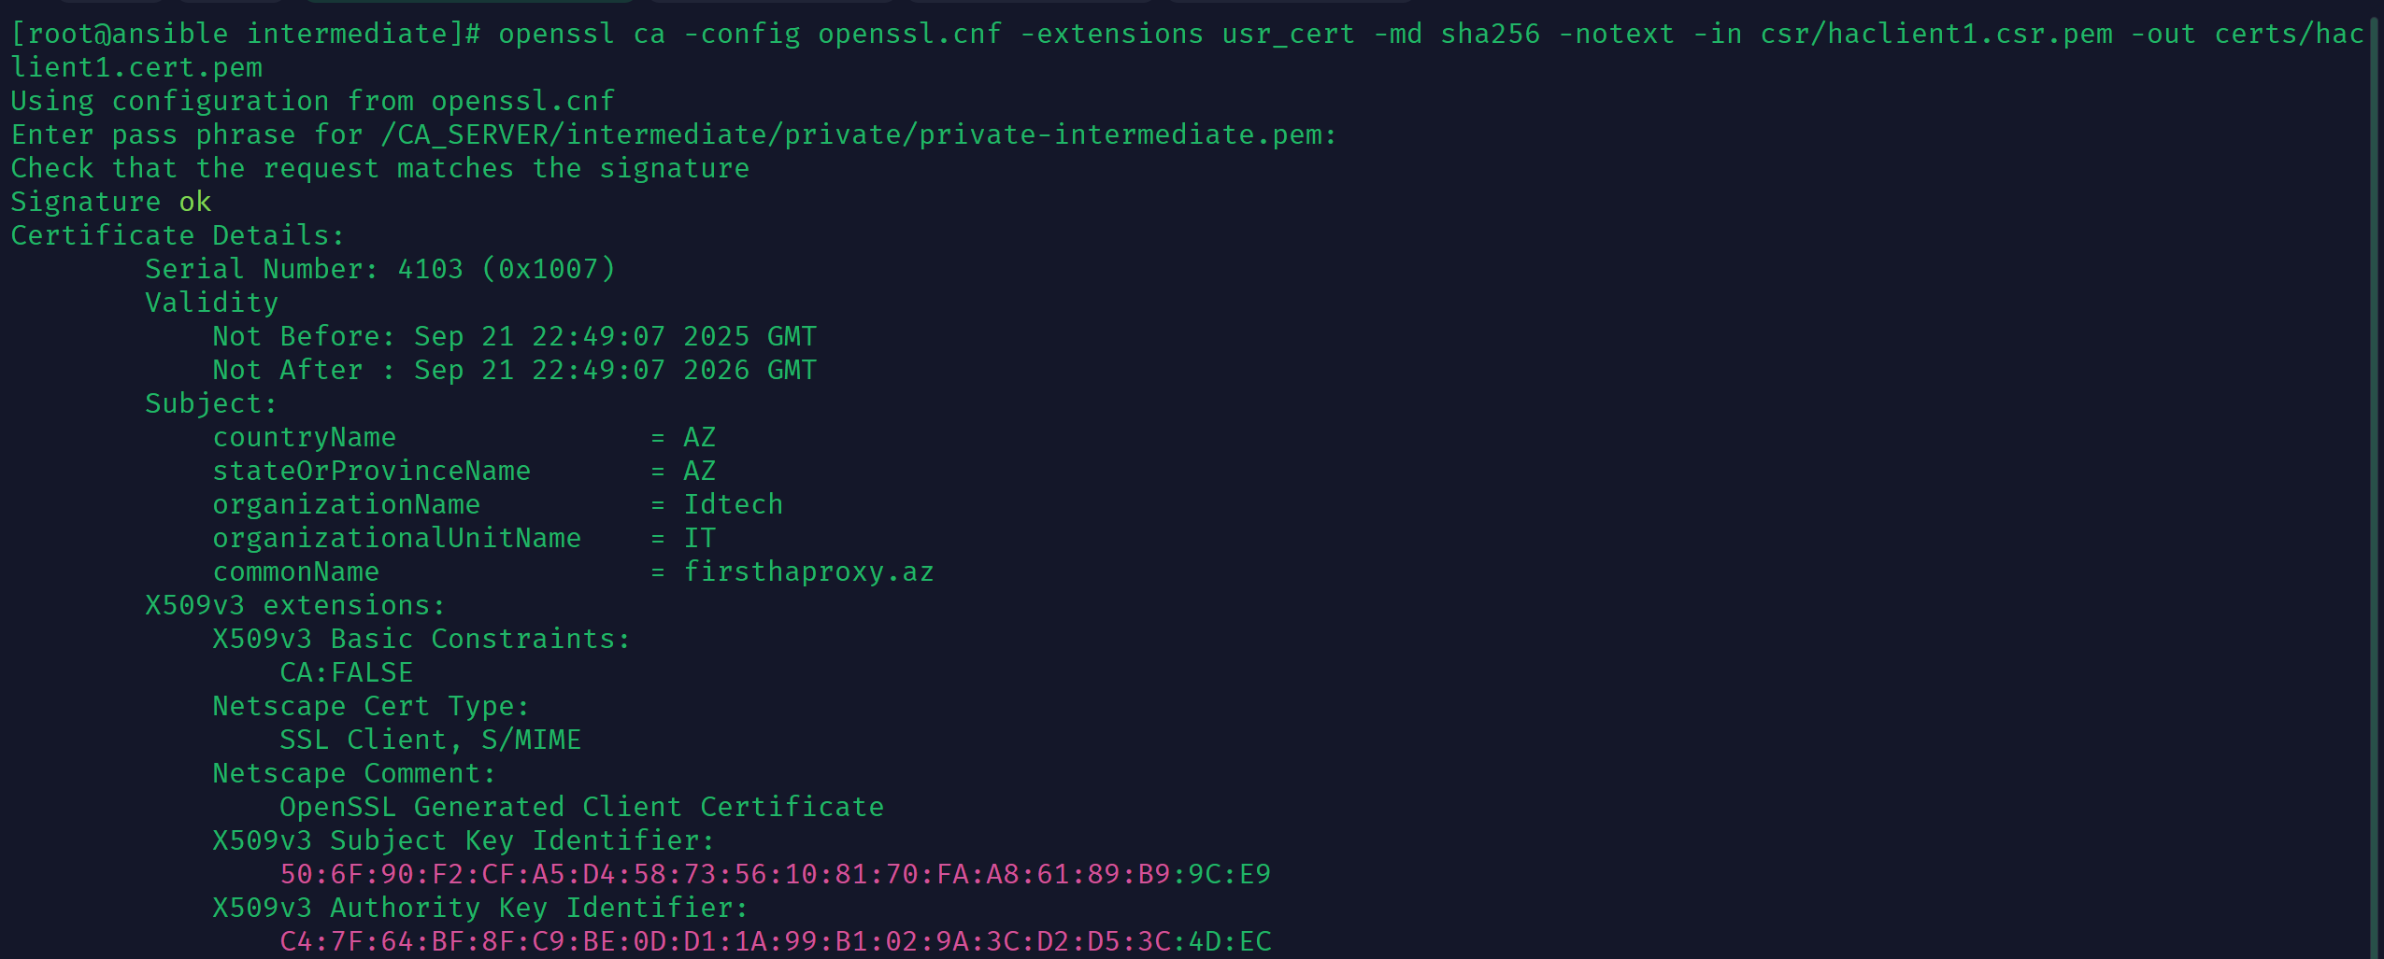

openssl ca -config openssl.cnf -extensions usr_cert -md sha256 -notext -in csr/haclient2.csr.pem -out certs/haclient2.cert.pem

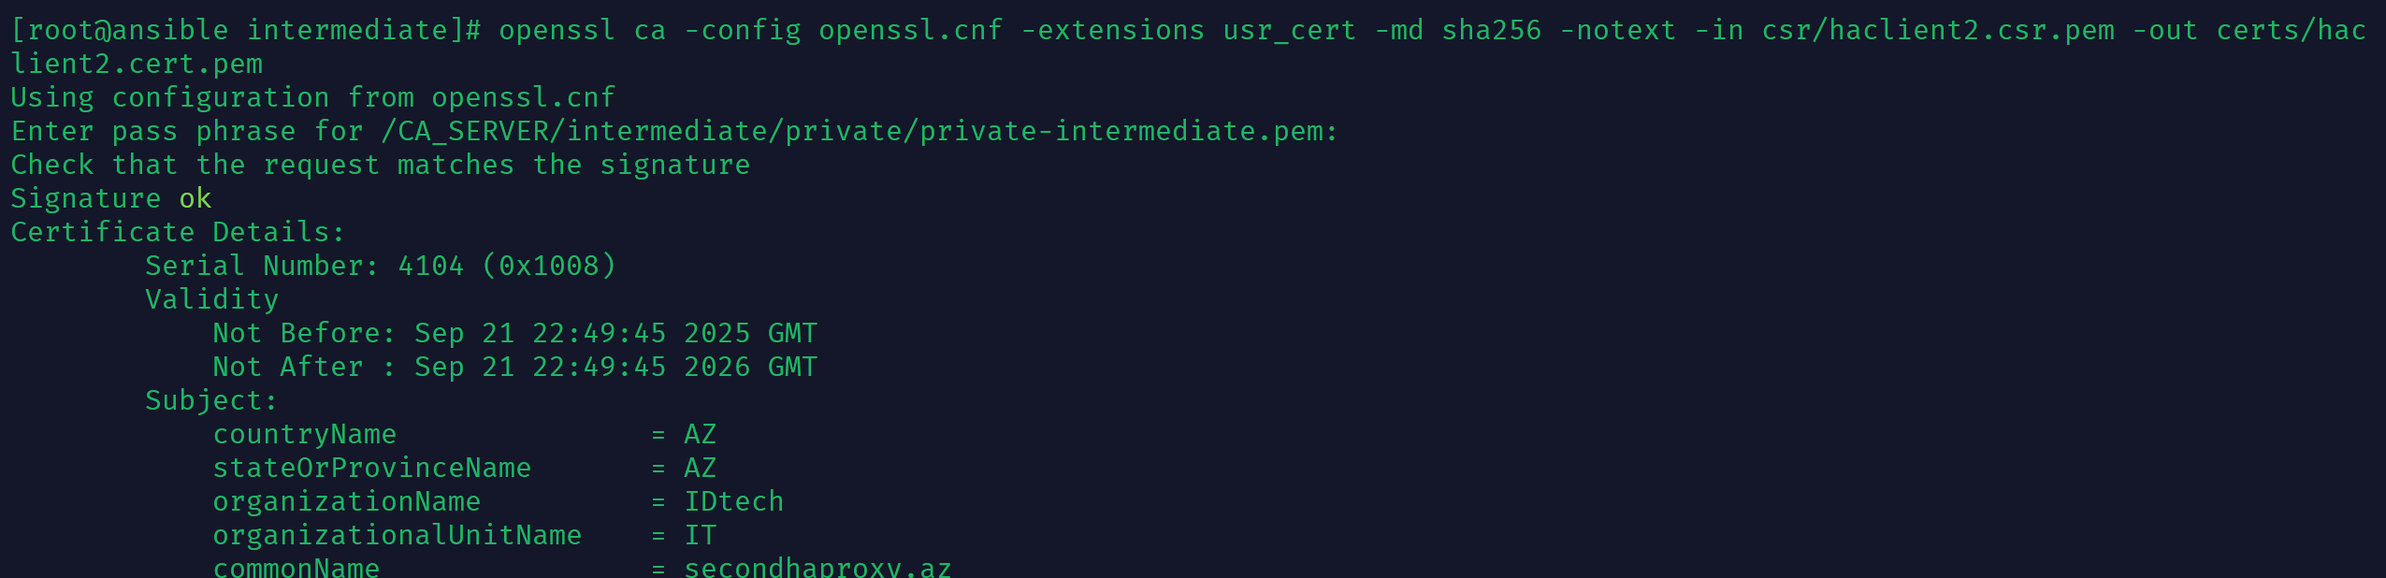

Verify: openssl x509 -in certs/haclient1.cert.pem -text -noout | grep DNS -B5 -A2

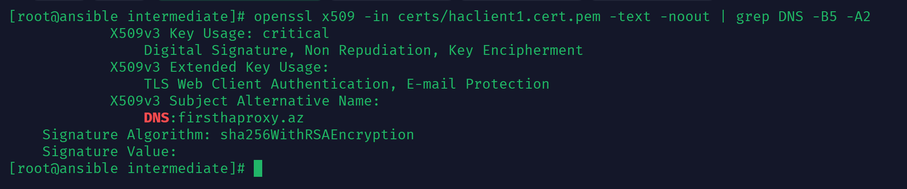

Verify: openssl x509 -in certs/haclient2.cert.pem -text -noout | grep DNS -B5 -A2

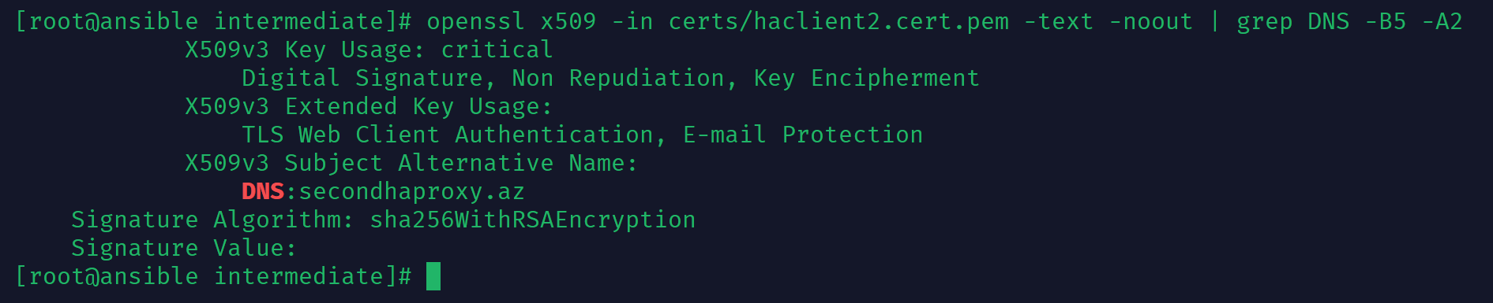

scp certs/haclient* root@192.168.232.130:/etc/pki/tls/certs



openssl pkcs12 -export -inkey private/private-haclient1.key -in certs/haclient1.cert.pem -certfile certs/ca.crt.pem -certfile certs/intermediate-ca.crt.pem -out certs/haclient1.pfx

openssl pkcs12 -export -inkey private/private-haclient2.key -in certs/haclient2.cert.pem -certfile certs/ca.crt.pem -certfile certs/intermediate-ca.crt.pem -out certs/haclient2.pfx

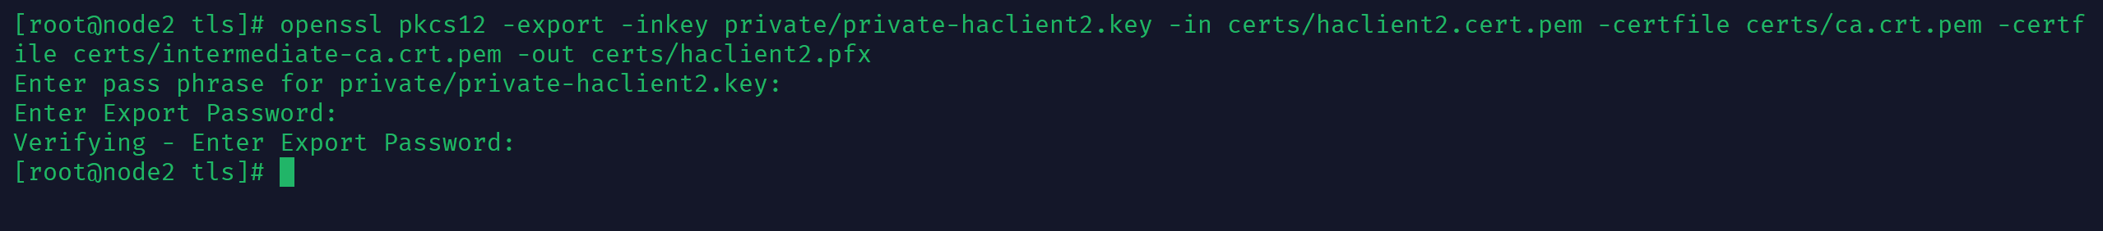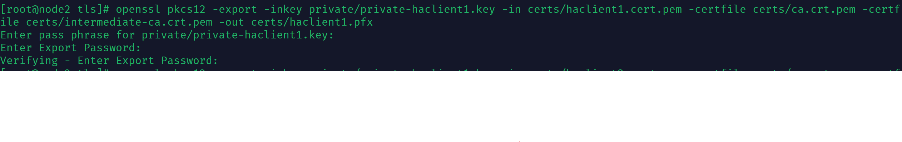

Server_cert:



Client_cert:



5. Configure frontends with ssl and crl send green bar without errors

cat certs/firsthaproxy.crt.pem certs/intermediate-ca.crt.pem private/private-firsthaproxy-no-aes.key > ca-chain-firsthaproxy.cert

cat certs/secondhaproxy.crt.pem certs/intermediate-ca.crt.pem private/private-secondhaproxy-no-aes.key > ca-chain-secondhaproxy.cert



Haproxy.cnf edit:

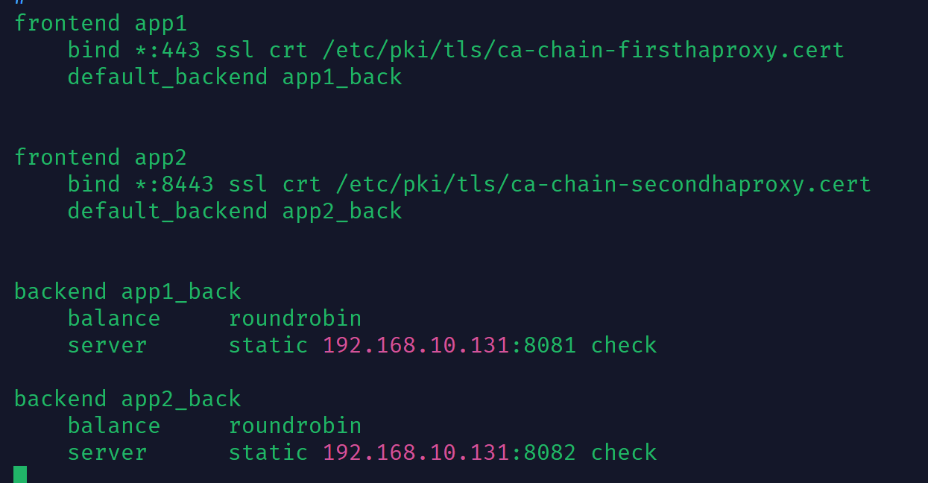

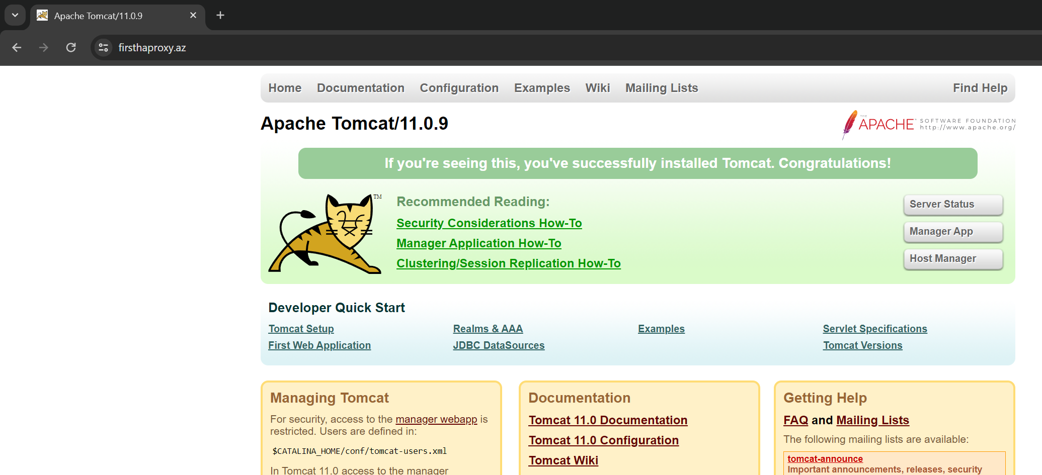



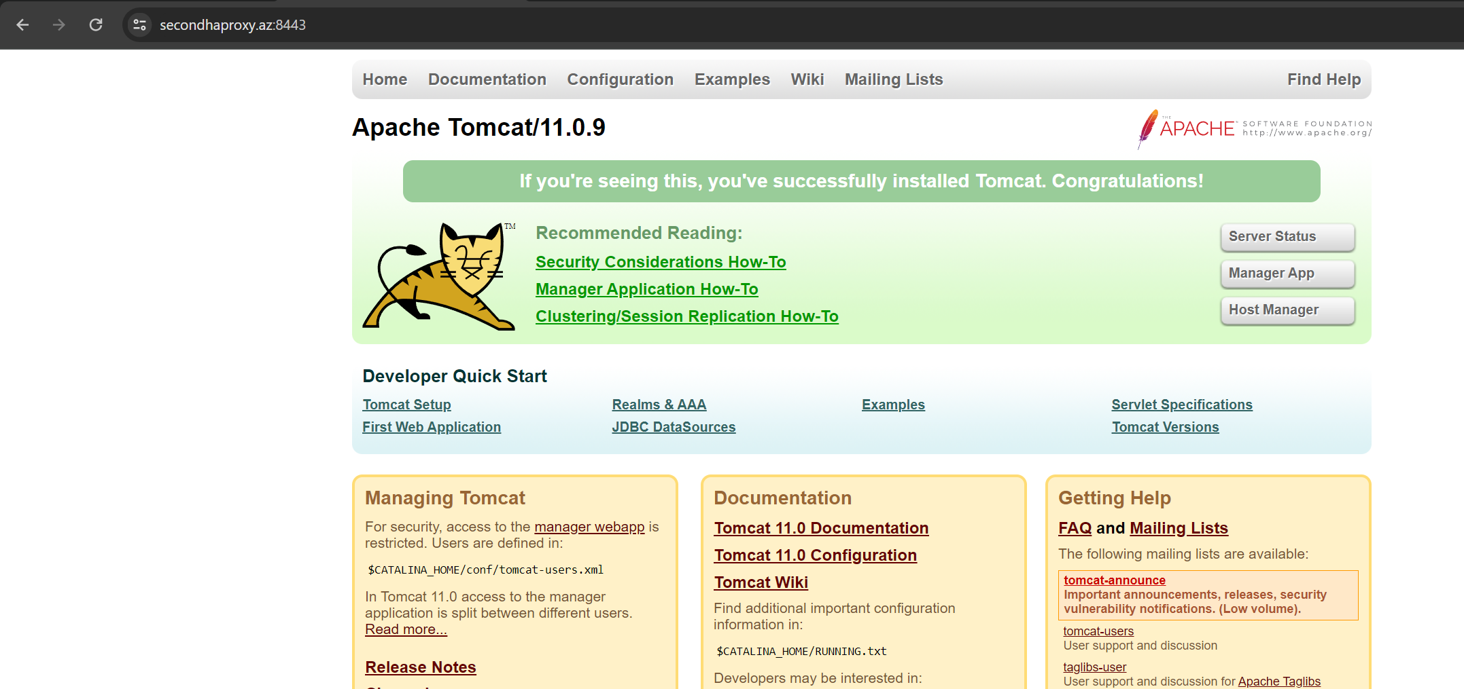

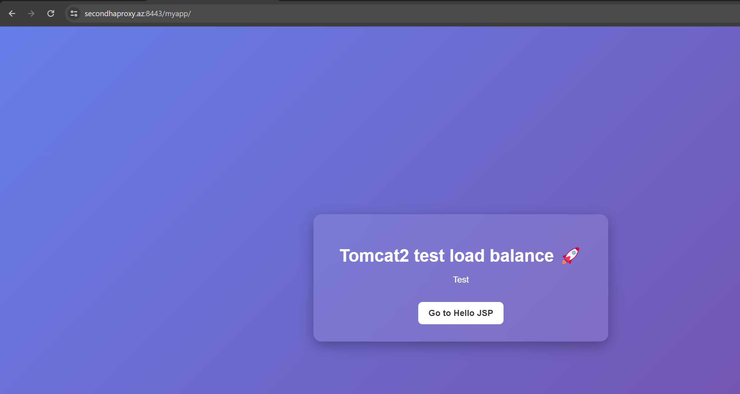

6. Revoke one of the client certs and send result on browser

openssl ca -config openssl.cnf -gencrl -out crl/root.crl.pem

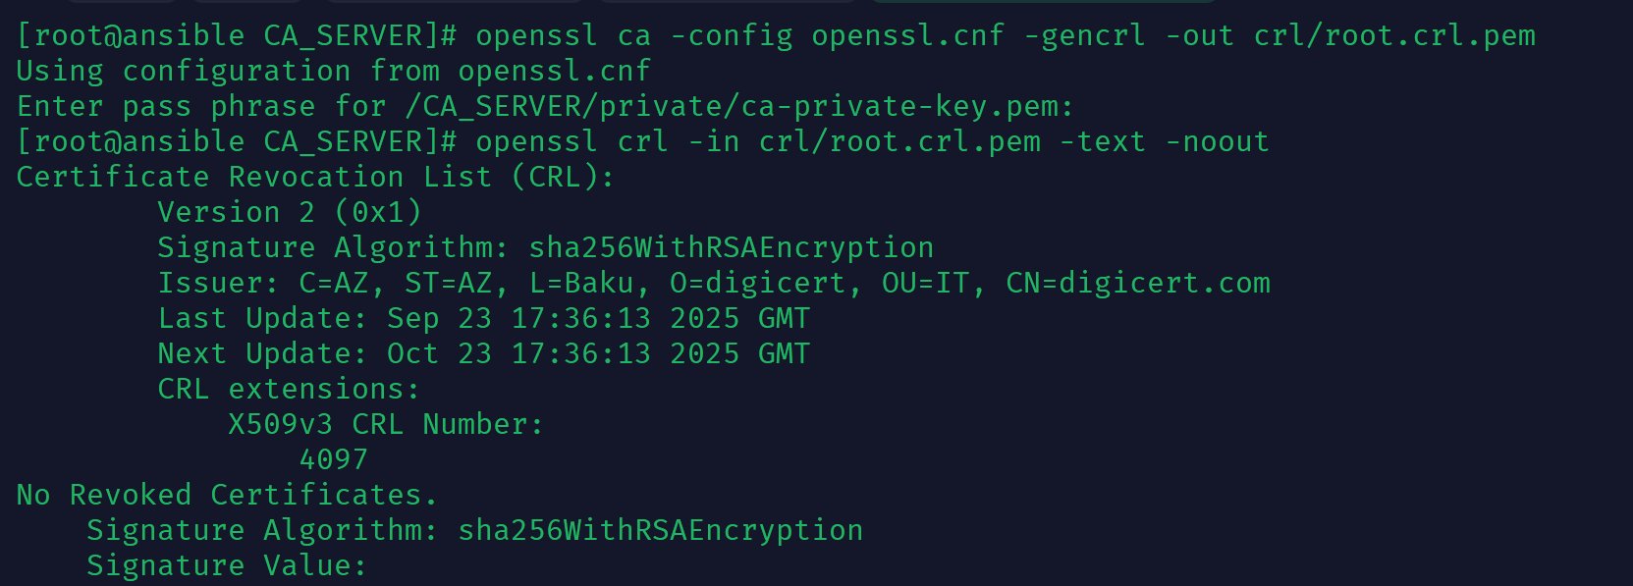

openssl ca -config openssl.cnf -gencrl -out crl/intermediate.crl.pem

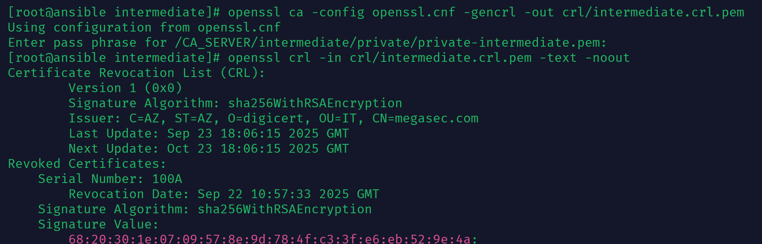

openssl ca -config openssl.cnf -revoke certs/haclient1.cert.pem

openssl ca -config openssl.cnf -gencrl -out crl/intermediate.crl.pem

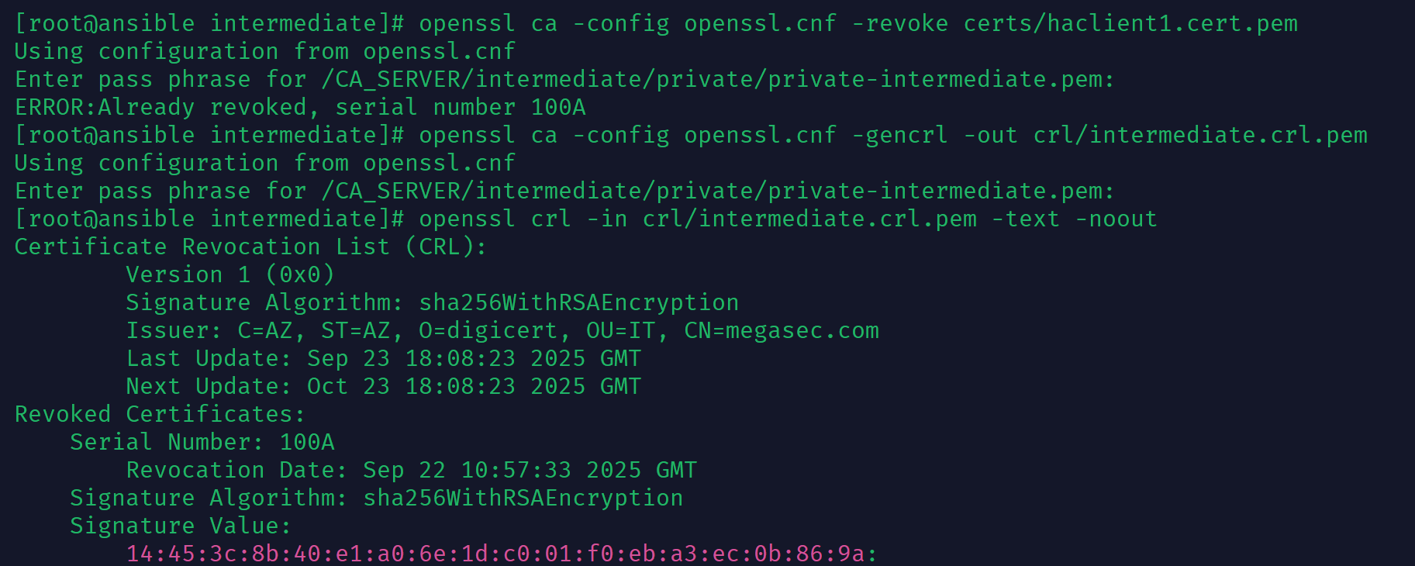

scp crl/intermediate.crl.pem ../crl/root.crl.pem root@192.168.10.129:/etc/pki/tls/crl



cat intermediate.crl.pem root.crl.pem > full-chain.crl.pem

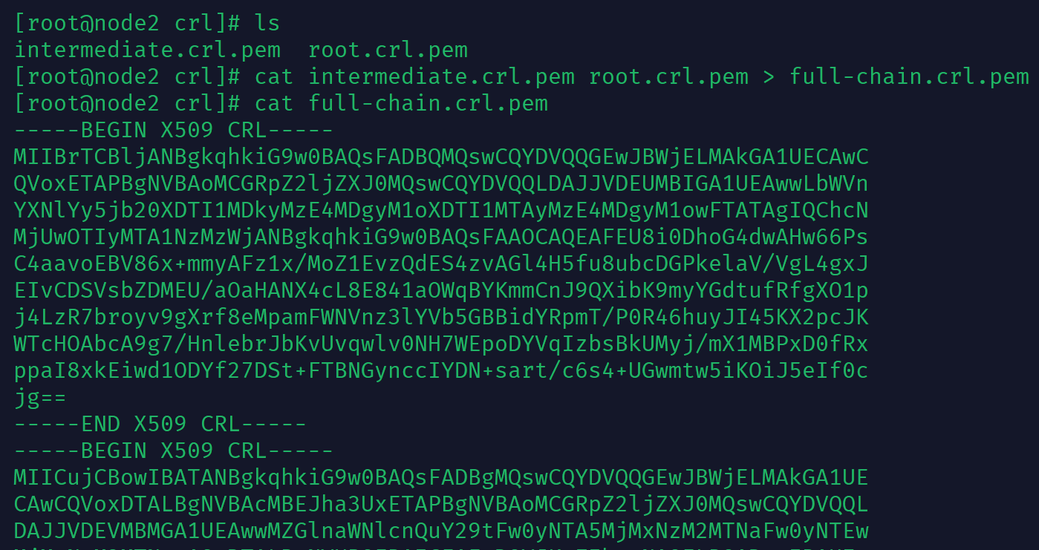

Firsthaporxy.az:

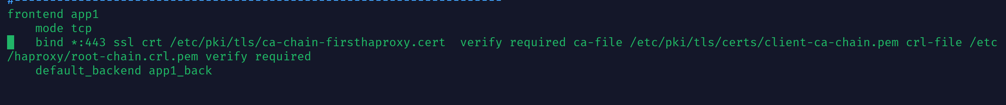

frontend app1

mode tcp

bind *:443 ssl crt /etc/pki/tls/ca-chain-firsthaproxy.cert verify required ca-file /etc/pki/tls/certs/client-ca-chain.pem crl-file /etc/haproxy/root-chain.crl.pem verify required

default_backend app1_back

frontend app2

bind *:8443 ssl crt /etc/pki/tls/ca-chain-secondhaproxy.cert

default_backend app2_back

backend app1_back

balance roundrobin

server static 192.168.10.131:8081 check

backend app2_back

balance roundrobin

server static 192.168.10.131:8082 check

systemctl restart haproxy



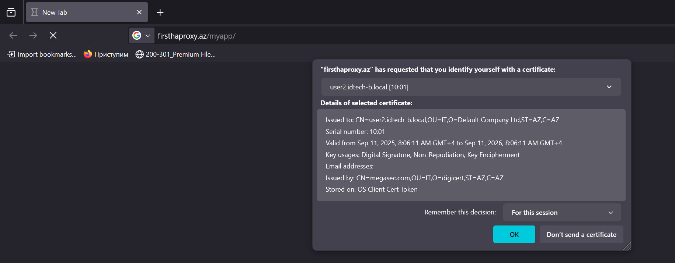

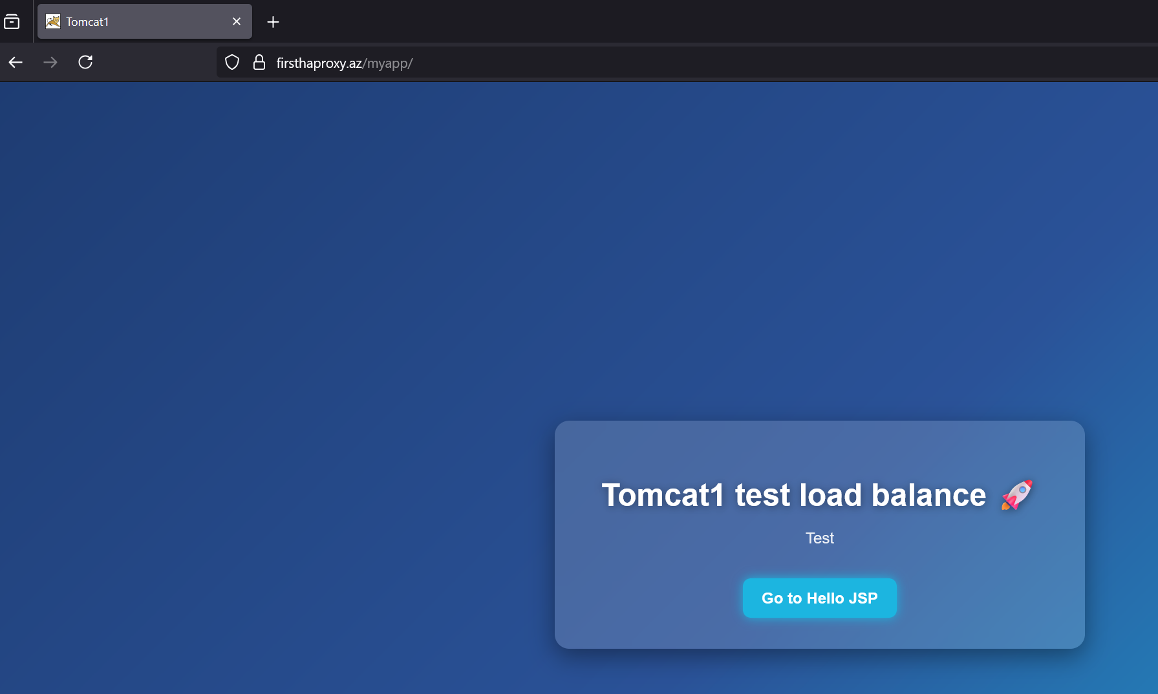

Secondhaporxy:

frontend app2

bind *:8443 ssl crt /etc/pki/tls/ca-chain-secondhaproxy.cert verify required ca-file /etc/pki/tls/certs/client-ca-chain.pem crl-file /etc/haproxy/root-chain.crl.pem

default_backend app2_back





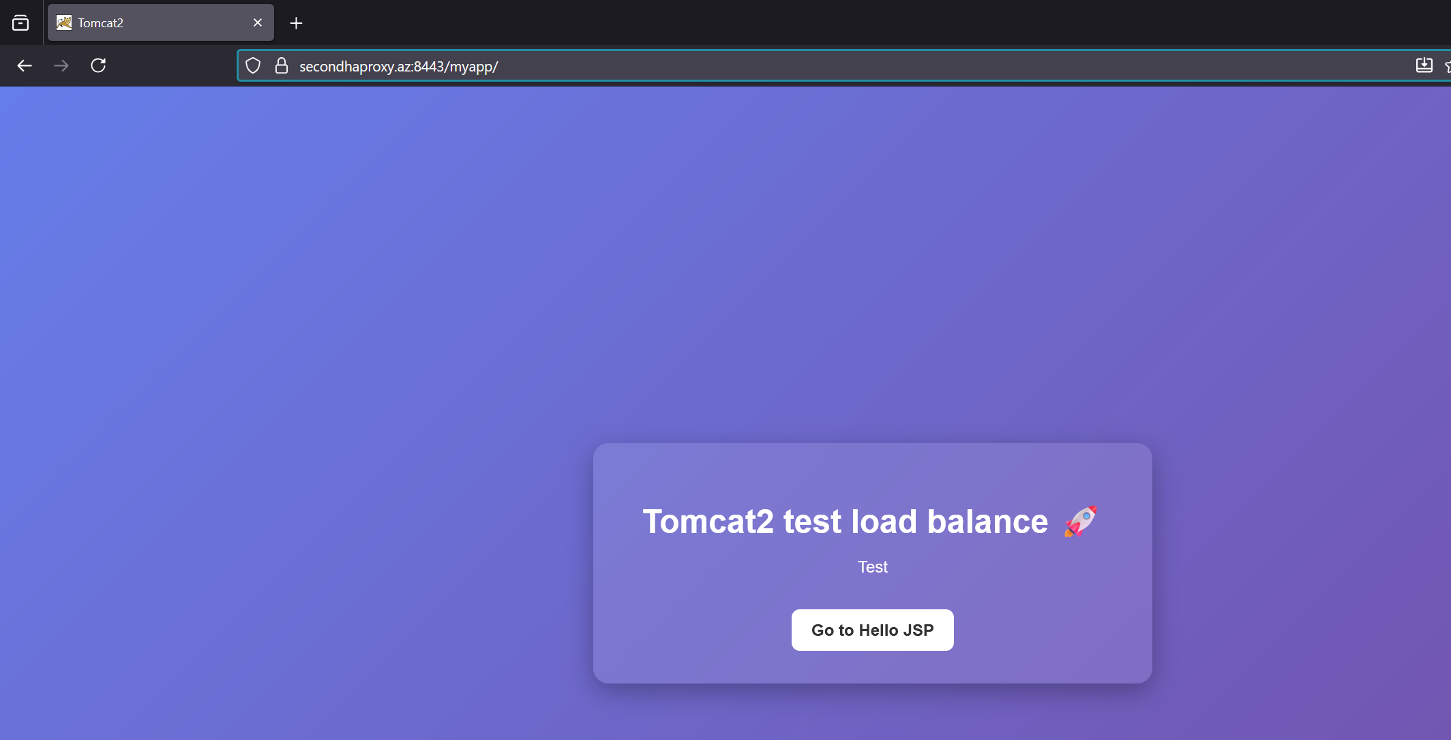

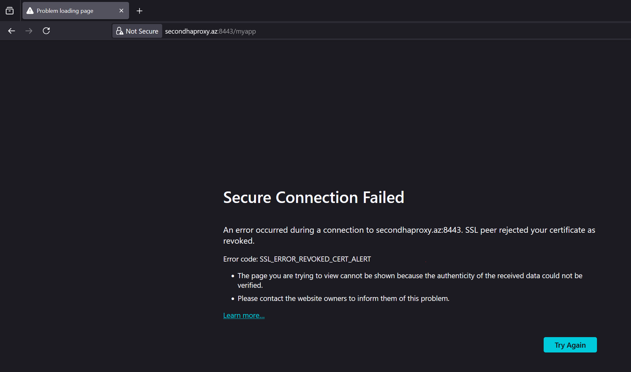

7. Redirect all http requests to https

frontend app1

bind *:80

redirect scheme https code 301 if !{ ssl_fc }

bind *:443 ssl crt /etc/pki/tls/ca-chain-firsthaproxy.cert verify required ca-file /etc/pki/tls/certs/client-ca-chain.pem crl-file /etc/haproxy/root-chain.crl.pem

default_backend app1_back

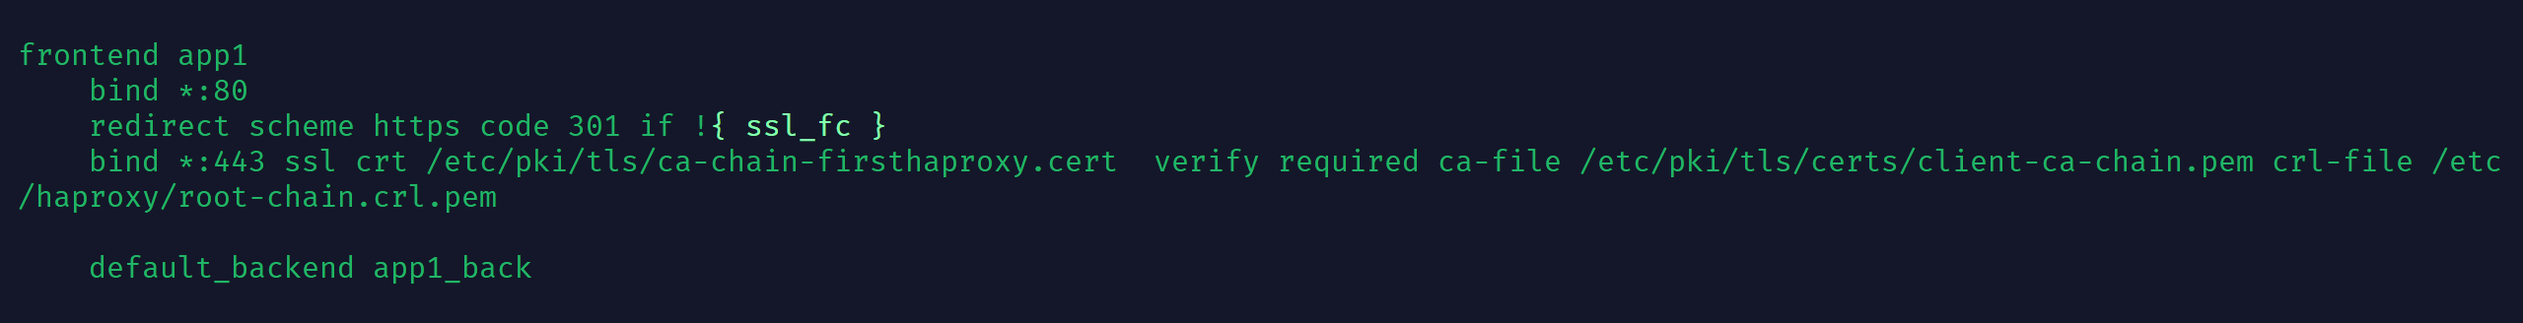

Systemctl restart haproxy

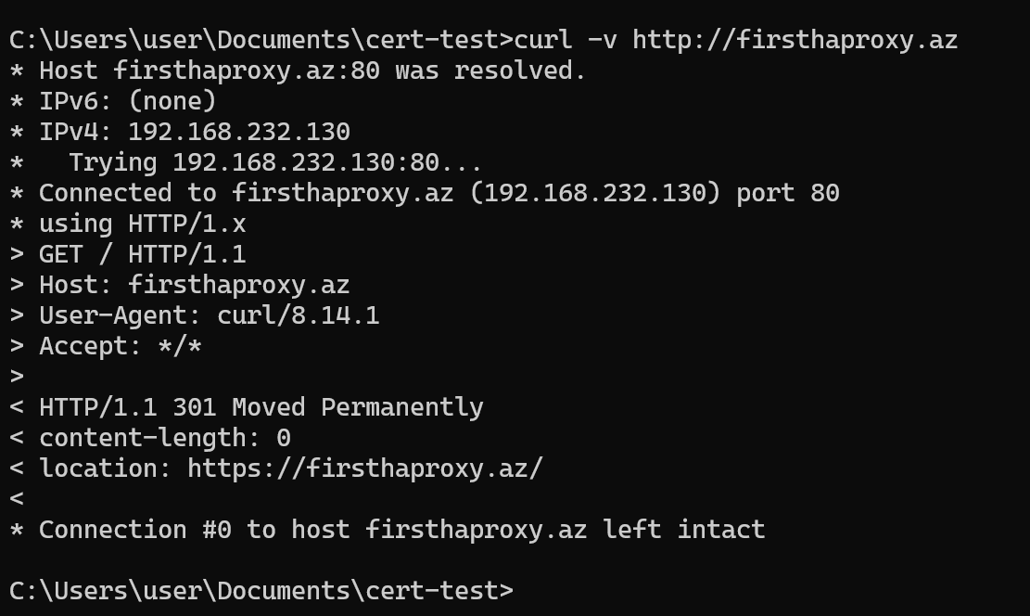

Additional:

HSTS (**HTTP Strict Transport Security**) is a web security policy that forces browsers to always use **HTTPS** instead of **HTTP**, preventing downgrade and cookie hijacking attacks.

HSTS configuration

frontend app1

bind *:80

redirect scheme https code 301 if !{ ssl_fc } bind *:443 ssl crt /etc/pki/tls/ca-chain-firsthaproxy.cert verify required ca-file /etc/pki/tls/certs/client-ca-chain.pem crl-file /etc/haproxy/root-chain.crl.pem

#HSTS

http-response set-header Strict-Transport-Security "max-age=31536000; includeSubDomains; preload"

default_backend app1_back

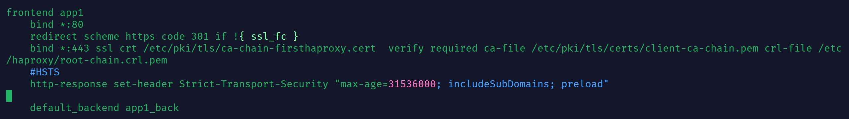

First request:

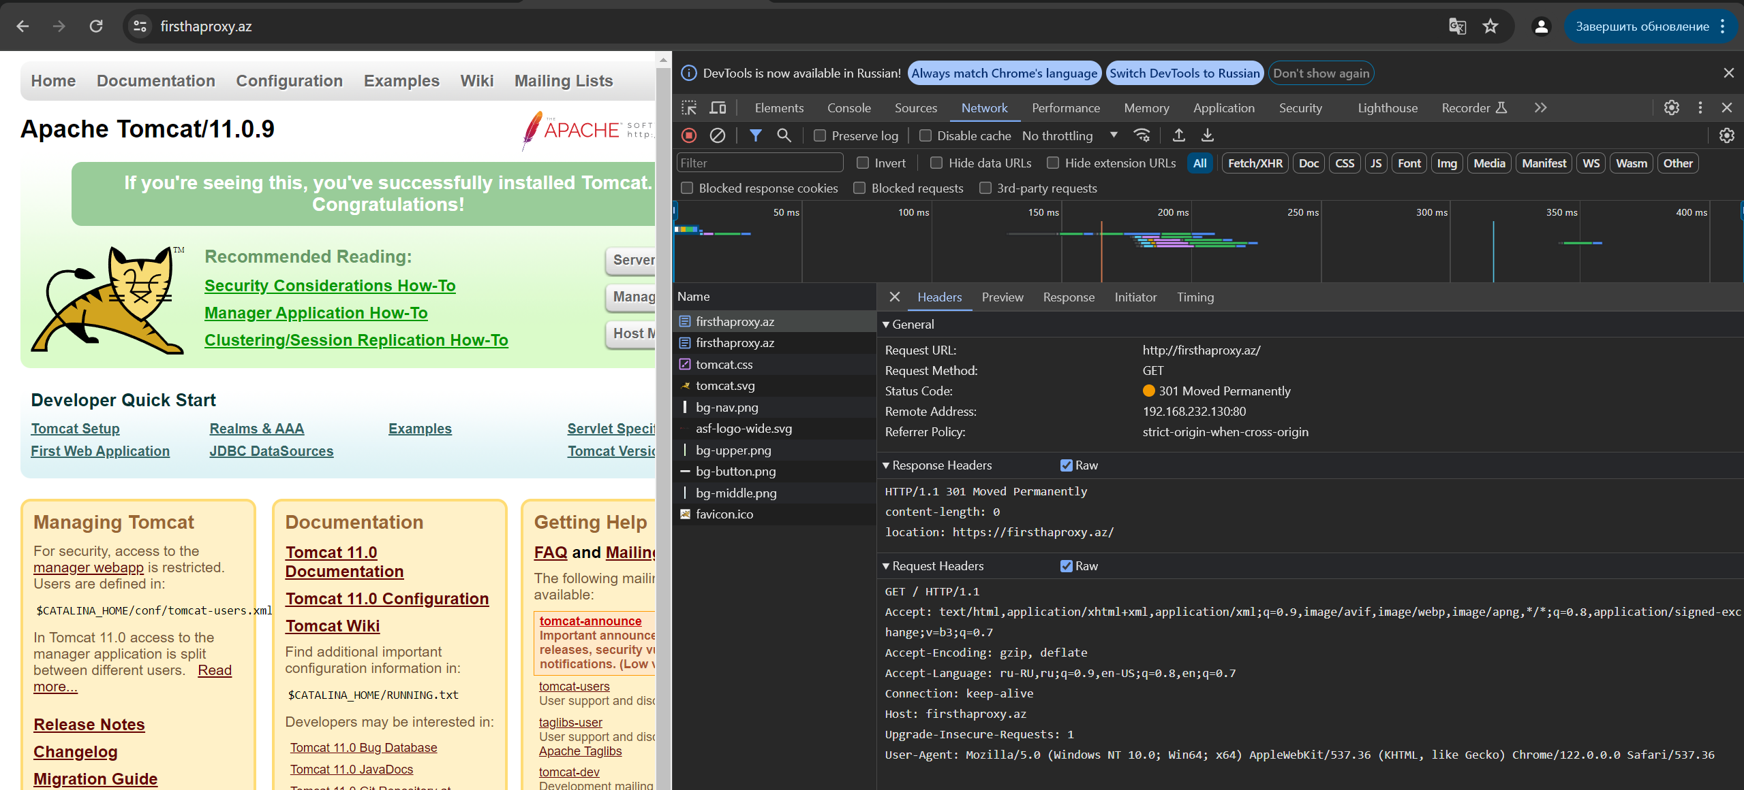

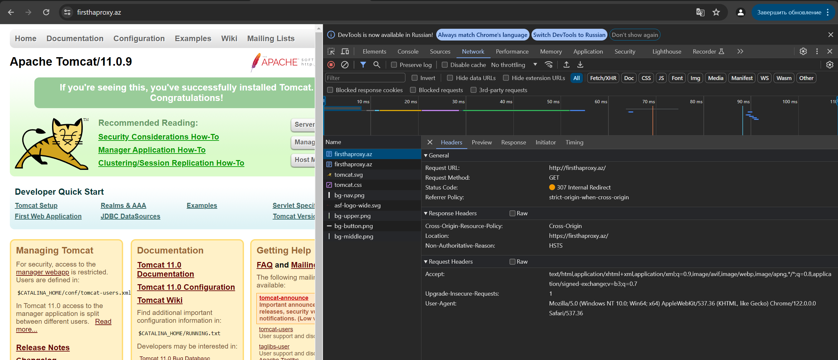

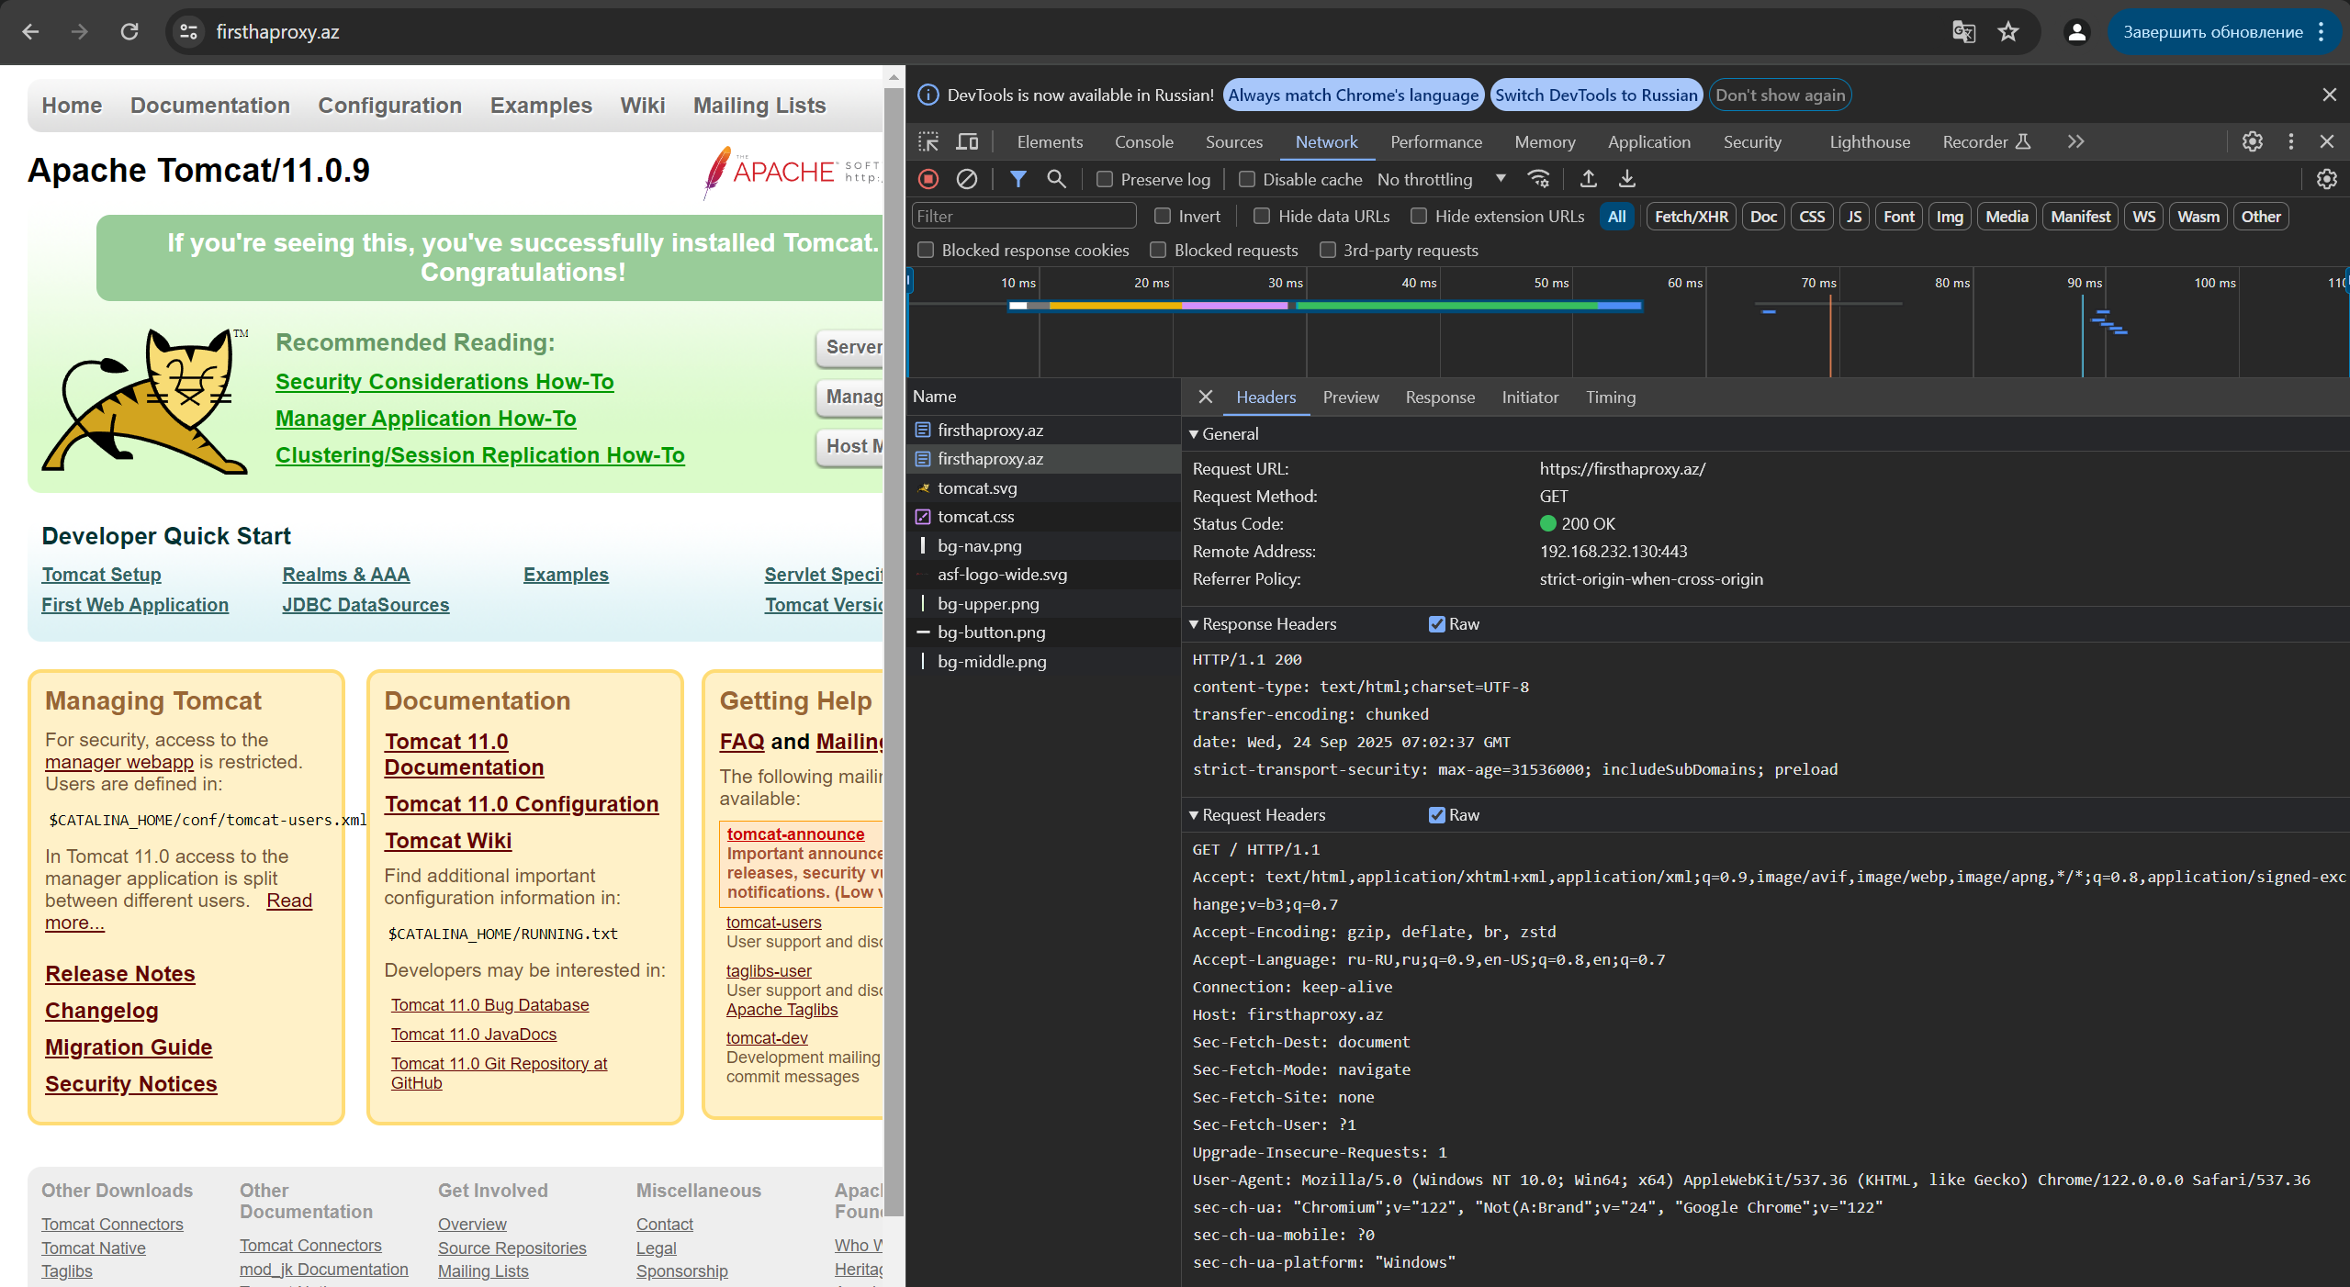

HSTS preload list:



We can delete hsts:



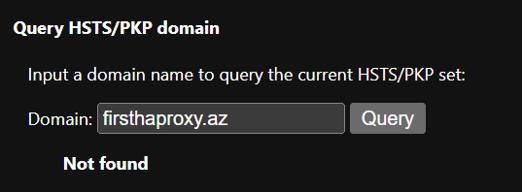

8. Configure stats page with password auth

userlist myusers

user aydin insecure-password 12345

user idtech password $6$0vXSA/oNsBDi5/A3$6UXfqoVzwZT7UKCiAeP5JDeBQER1GLtXmLZGrLQD1WUD75TCjr83LqToyD4GU8i9GB7nXIoi7tL11OAoapw0M1

listen stats

bind *:8081

stats enable

stats hide-version

stats show-node

stats uri /haproxy-stats

# stats auth username:parol

stats refresh 20s

http-request auth unless { http_auth(myusers) }

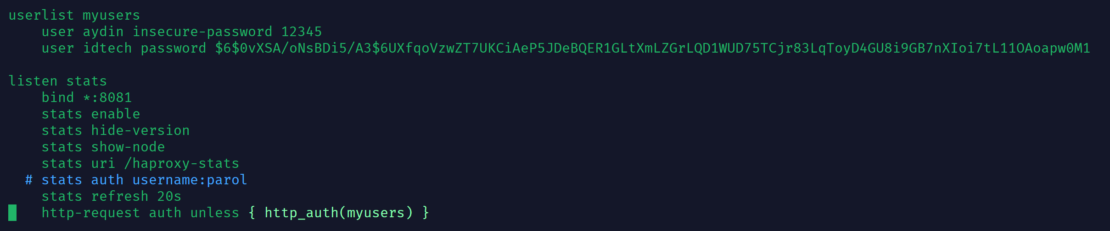

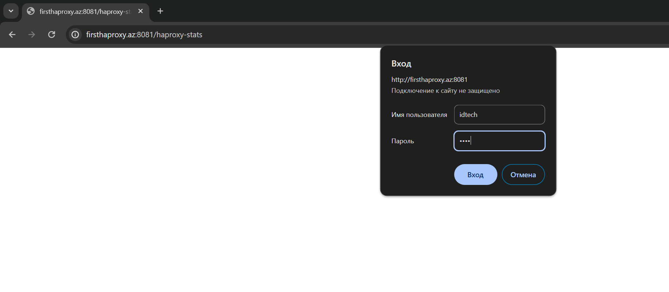

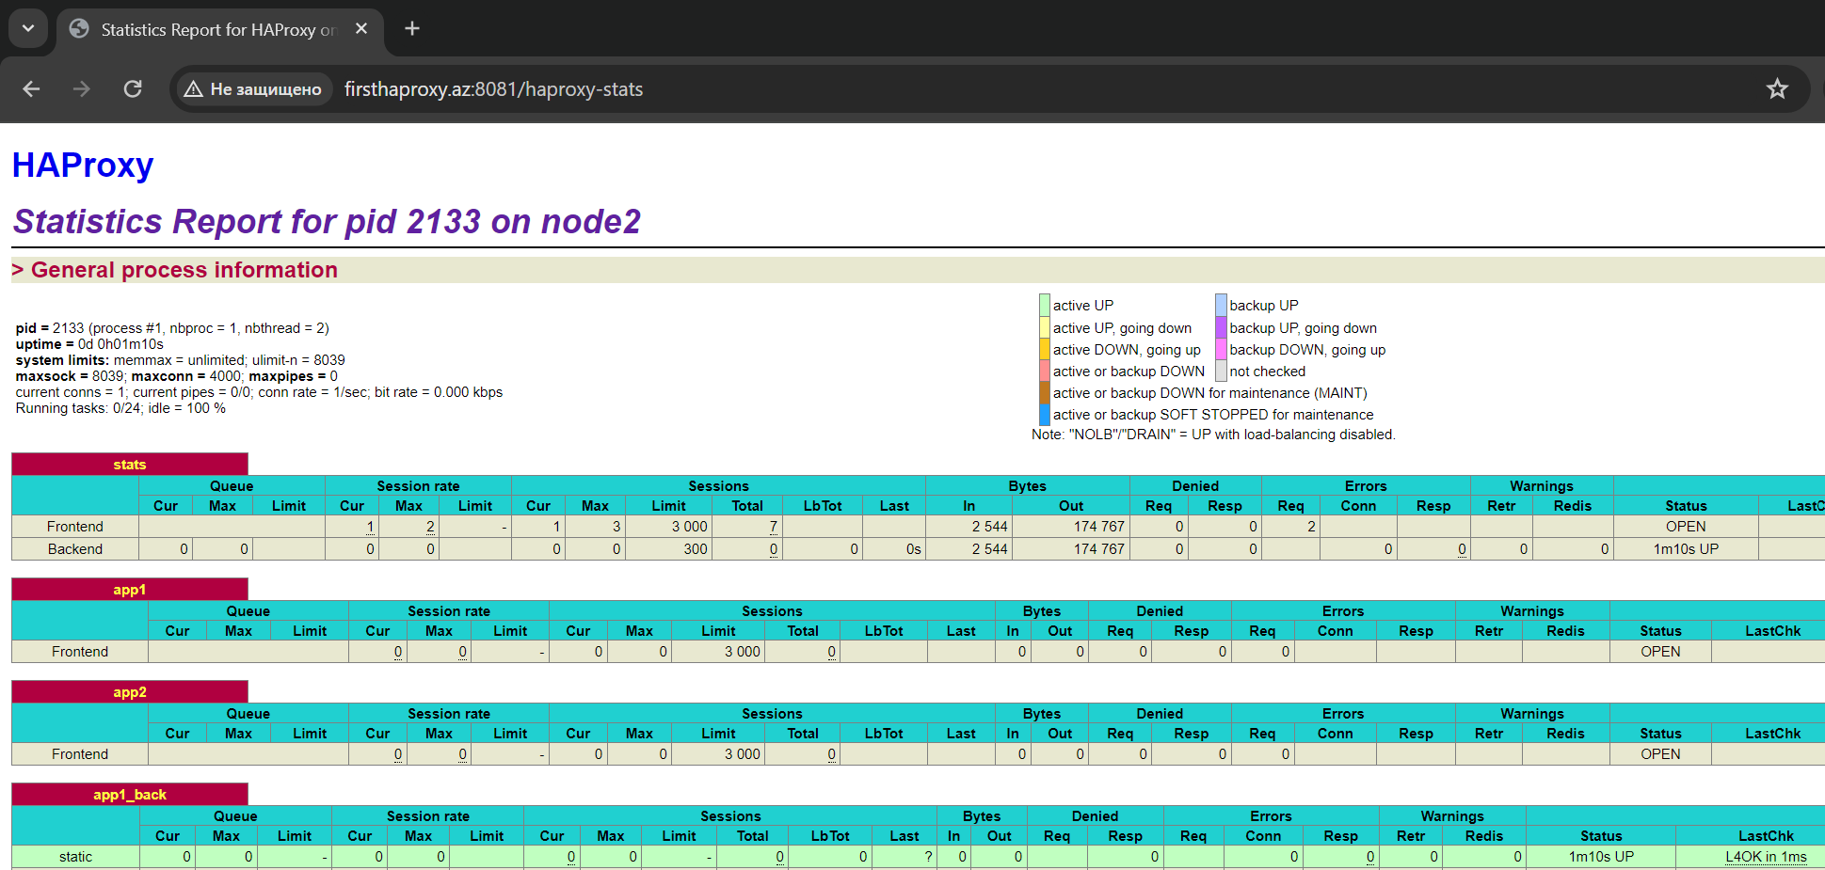

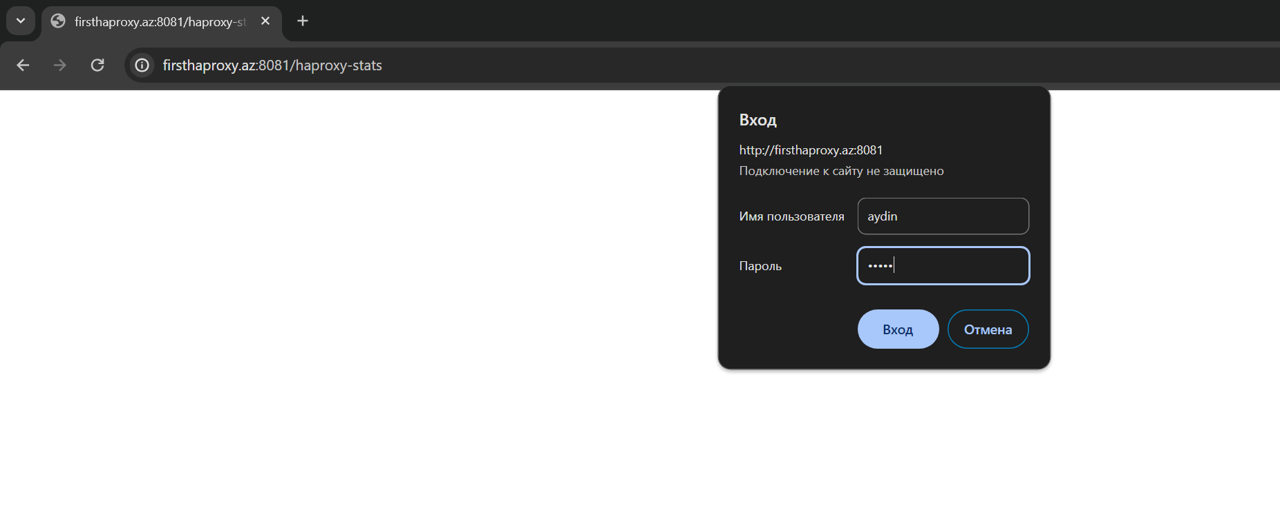

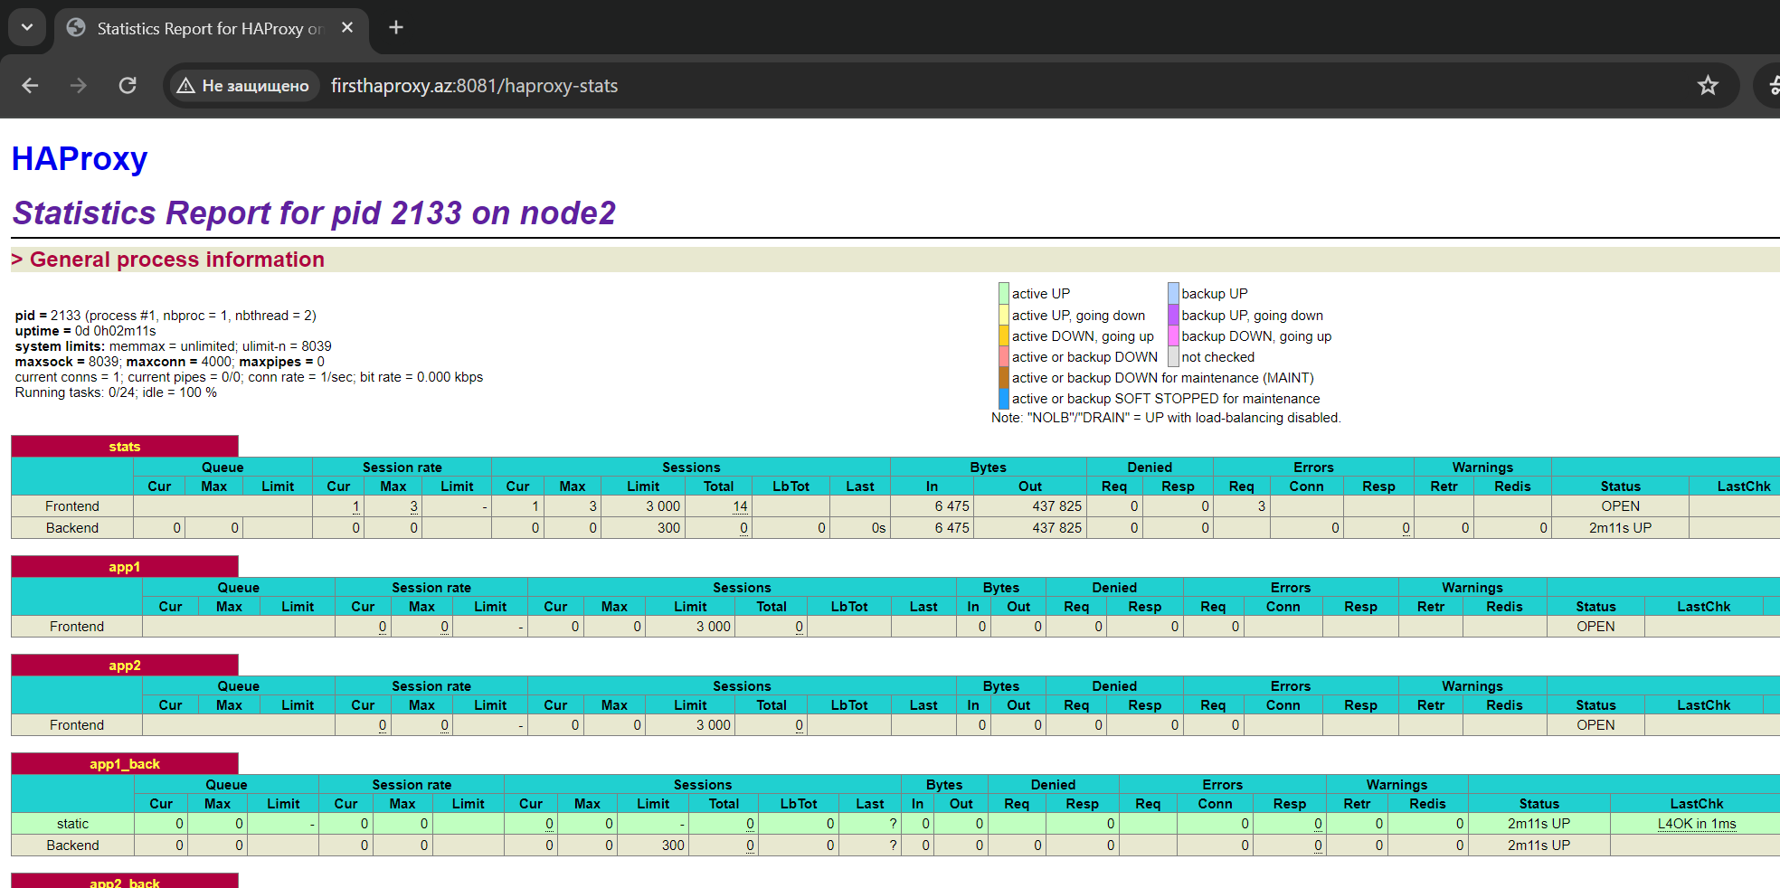

9. Configure basic auth

9.1 with unsecure password

9.2 with encrypted password

userlist myusers

user aydin insecure-password 12345

user idtech password <hash>



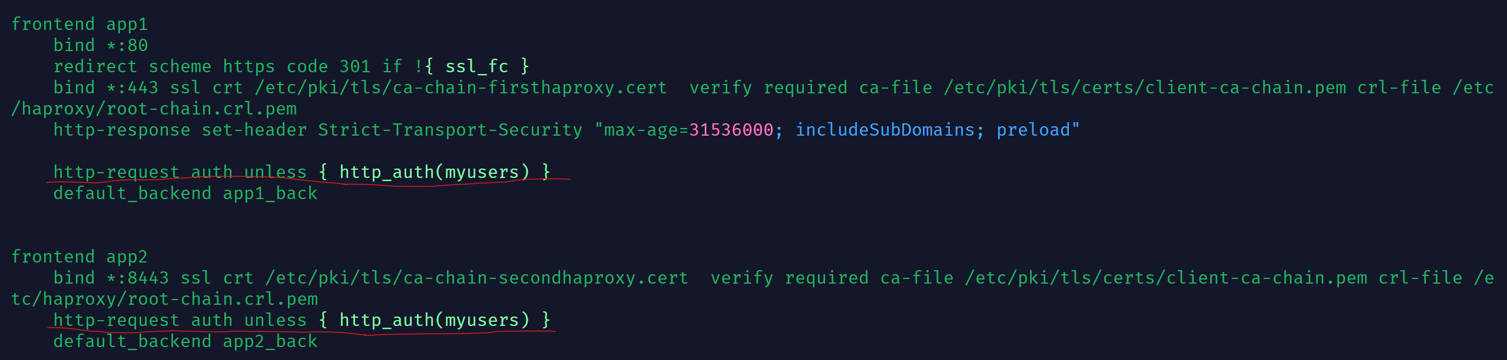

systemctl restart haproxy

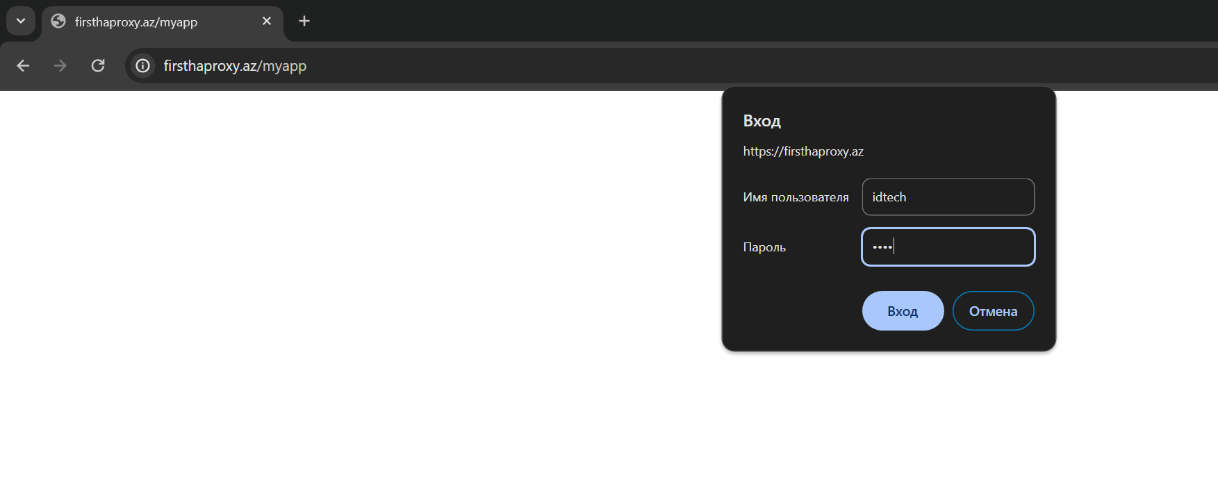



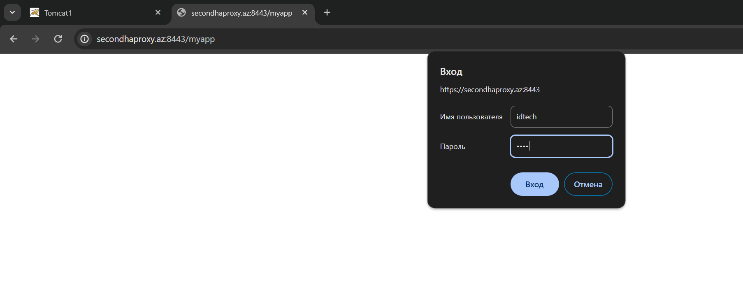



10. Add ACL for PATH BEGIN, PATH END , Source address, domin name, and configure

correct, appropriate backend

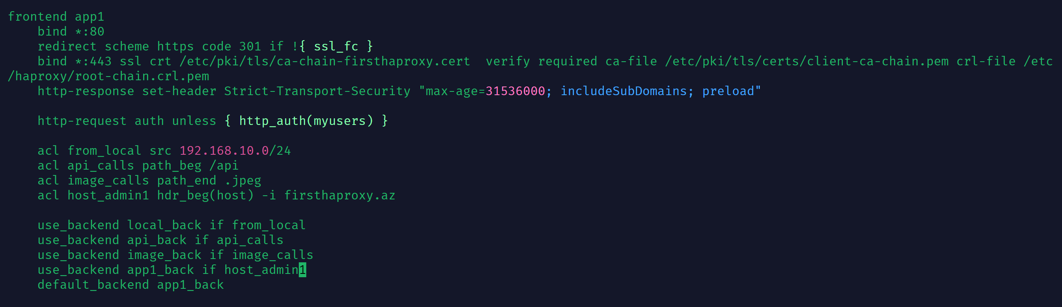

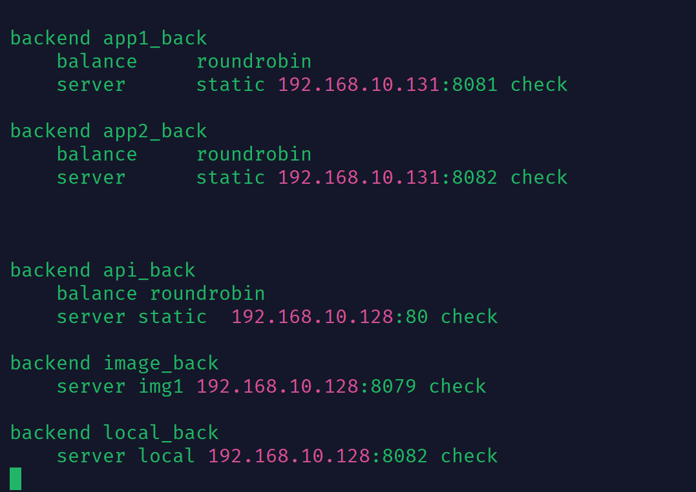





This error happend because I don’t add this IP address to SAN (Subject Alternative Name) Because I can’t predict that’s why I add only firsthaproxy.az

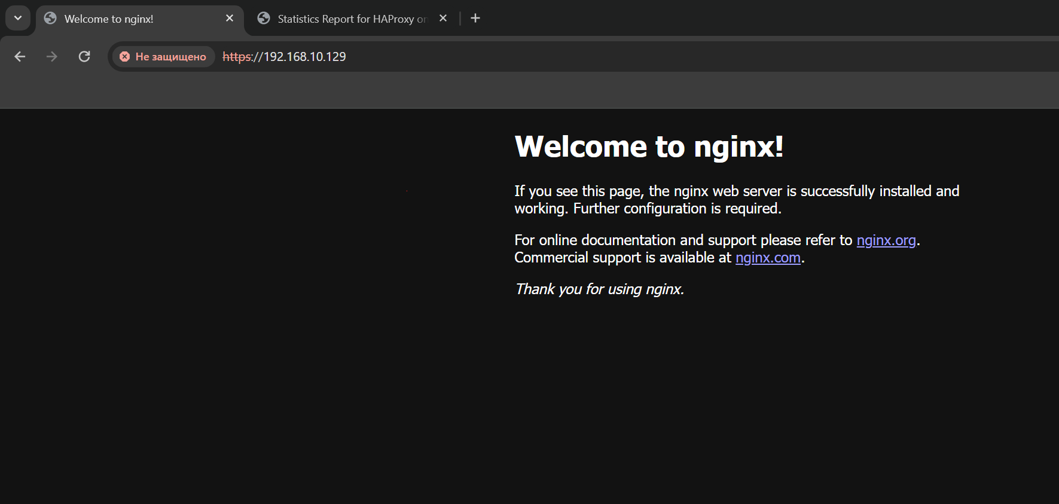

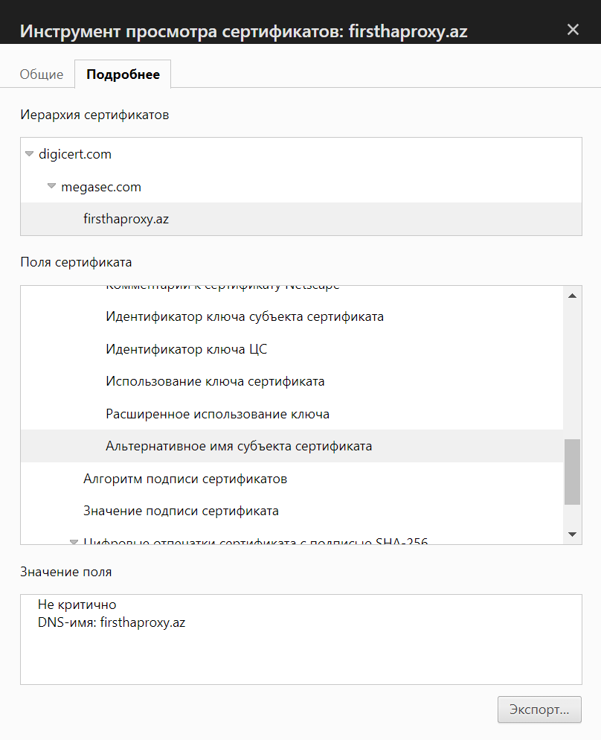

11. Configure tcp load balancing ( with check)

For cheching tcp load balancing I configure mysql container:

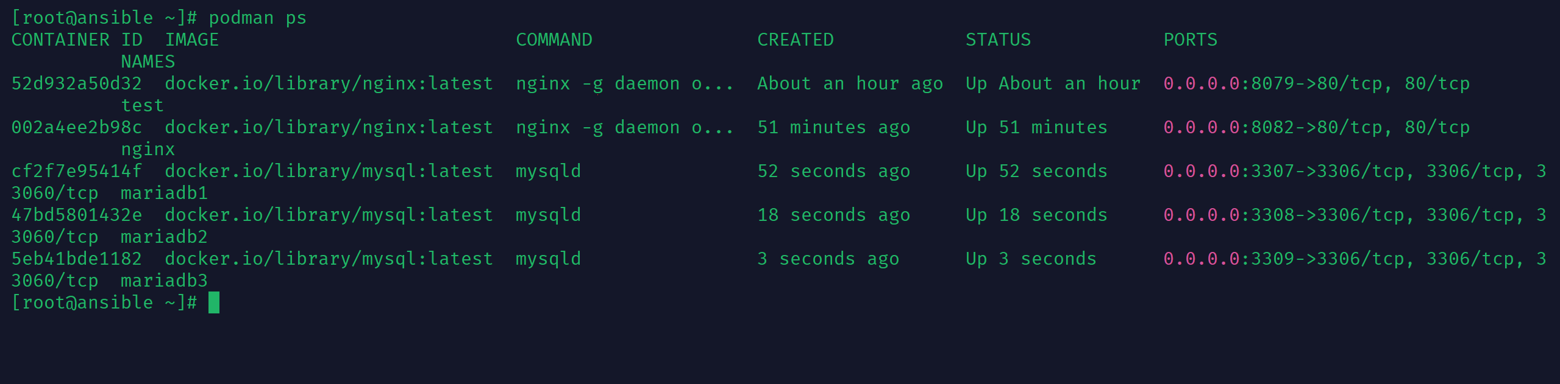

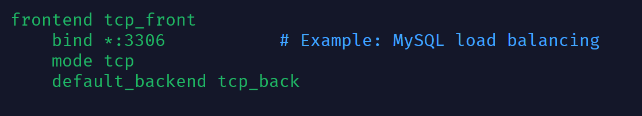

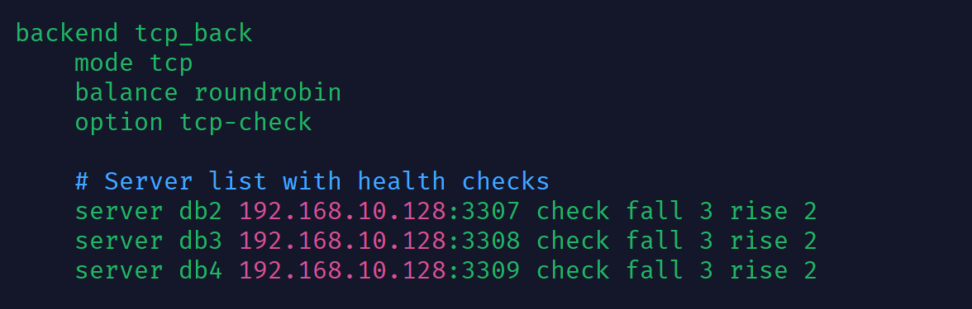

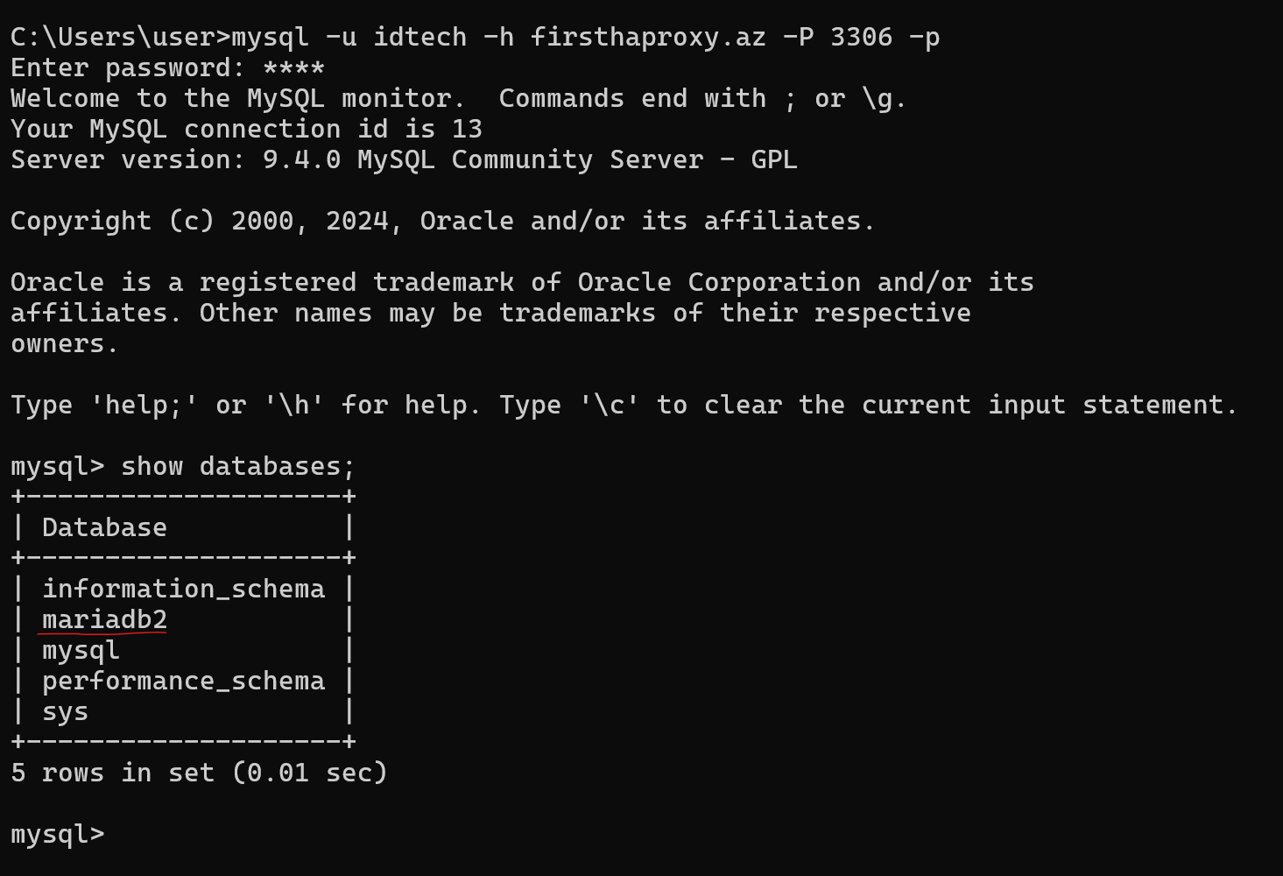

After that I will try to exit and connect again:

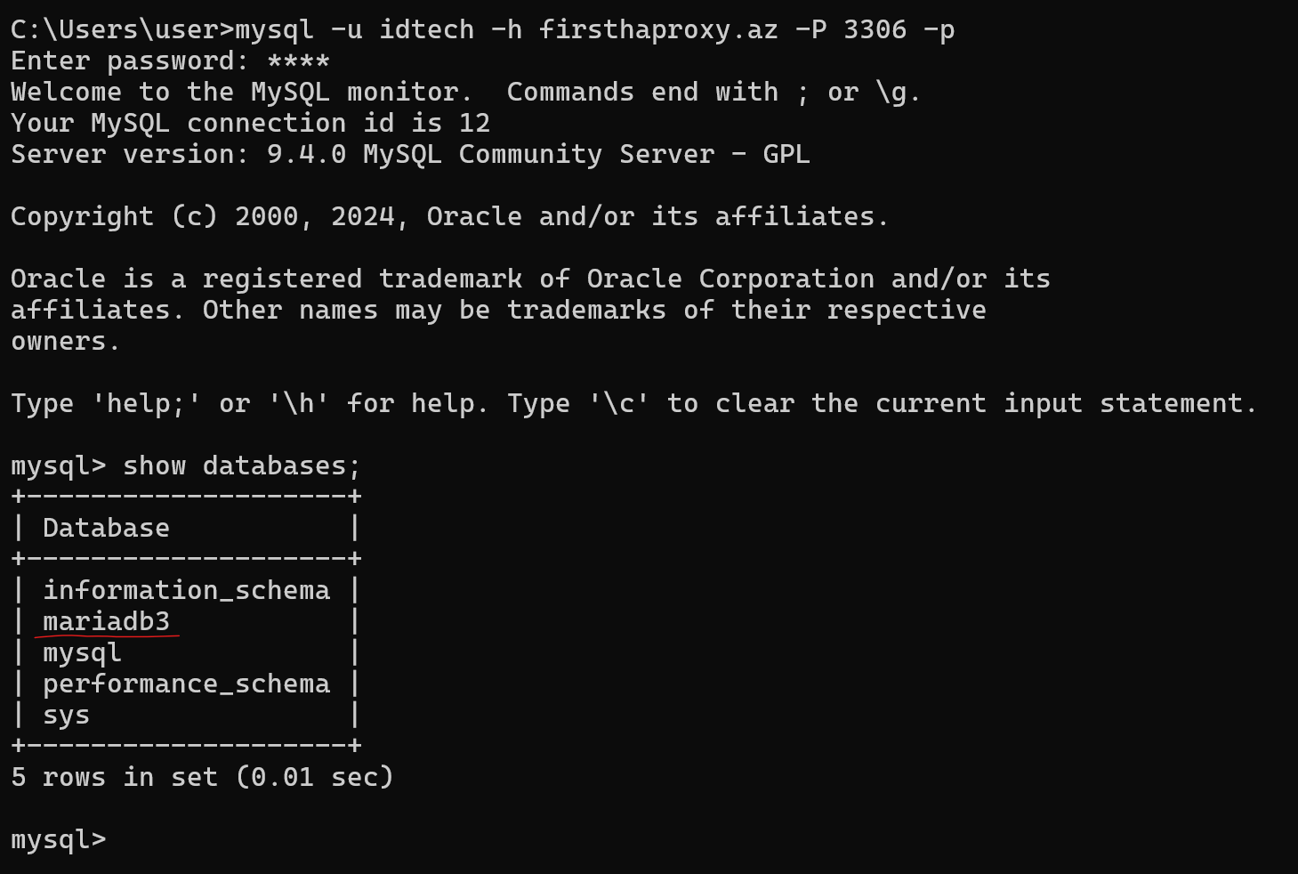

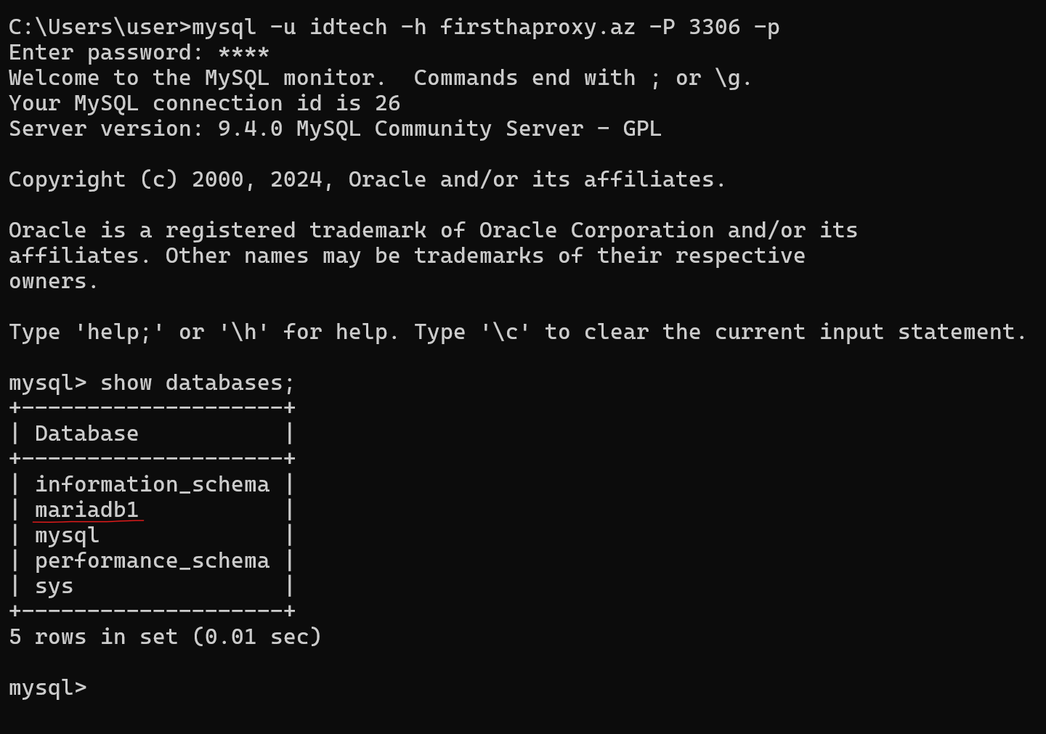

12. Install second Haproxy

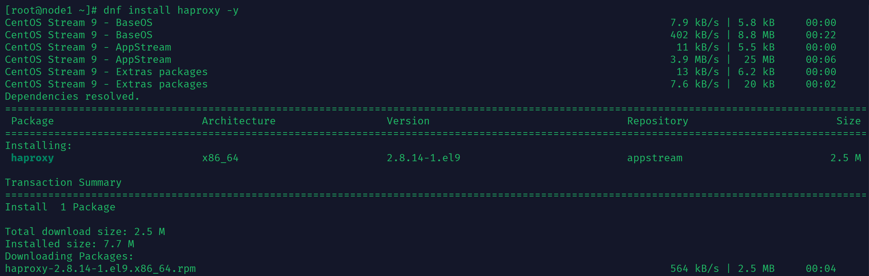

12.1 Copy config from first haproxy

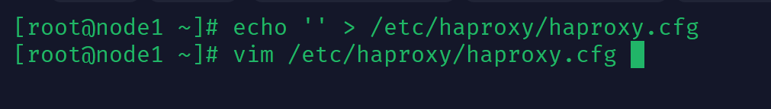

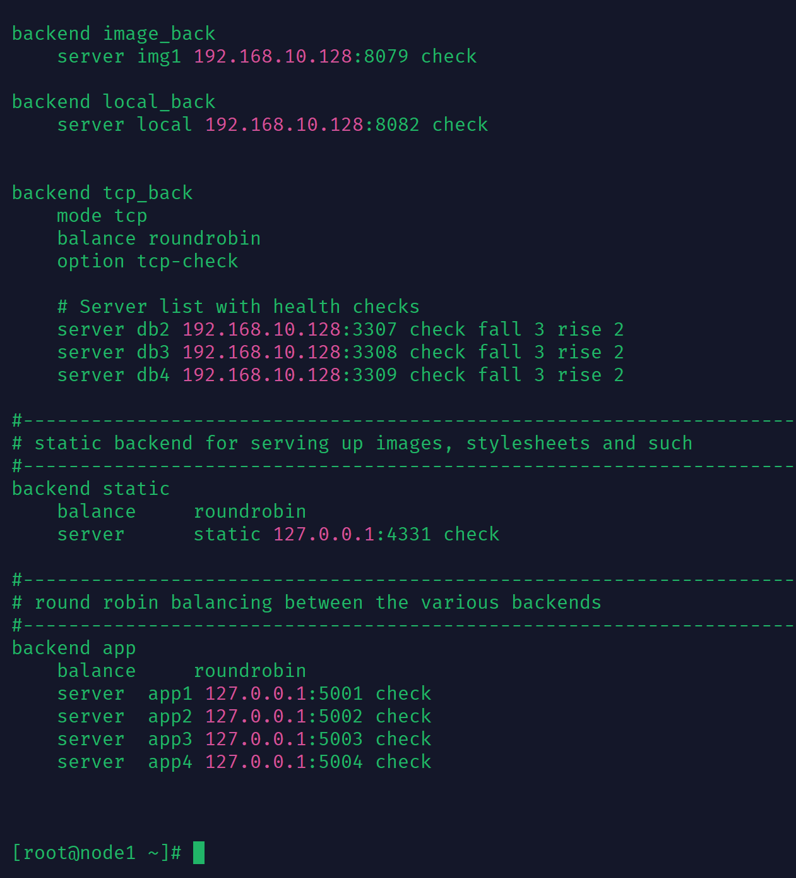

12.2 Edit same configs if required

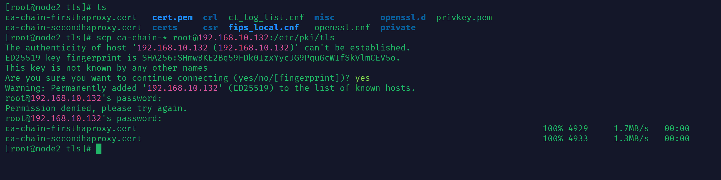

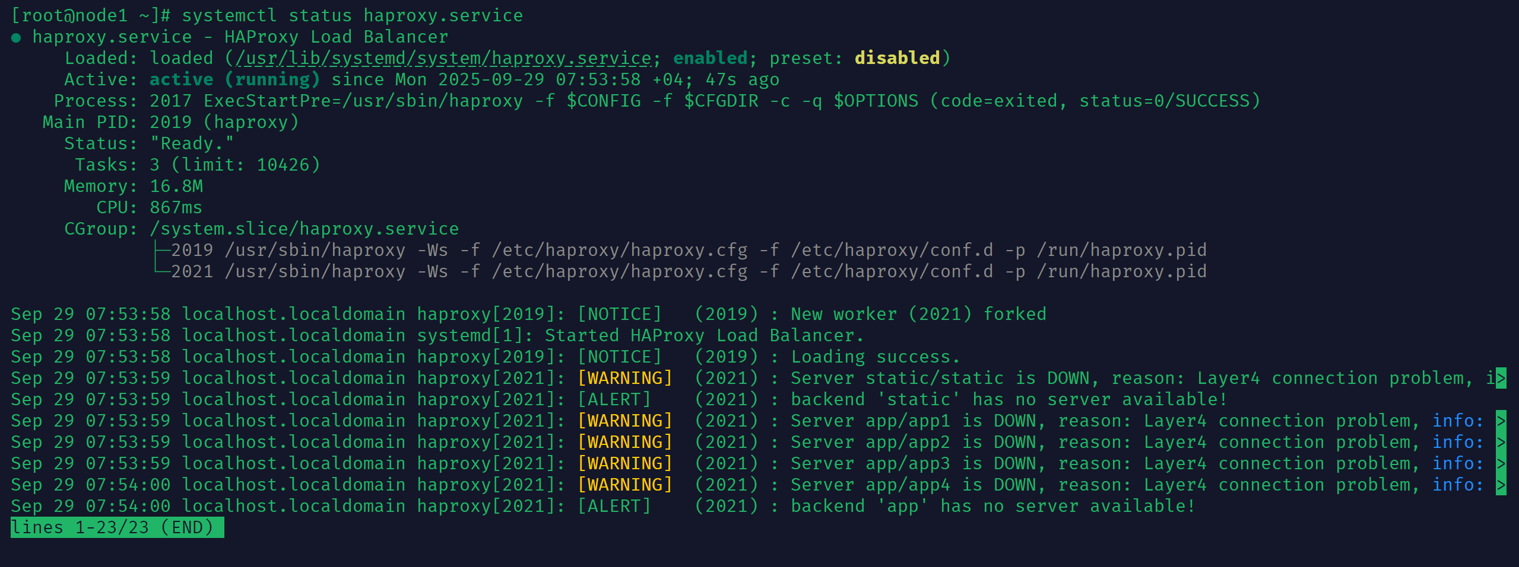

13. Install the keepalived on both servers

13.1 select one virtual ip and configure keepalived

Node2

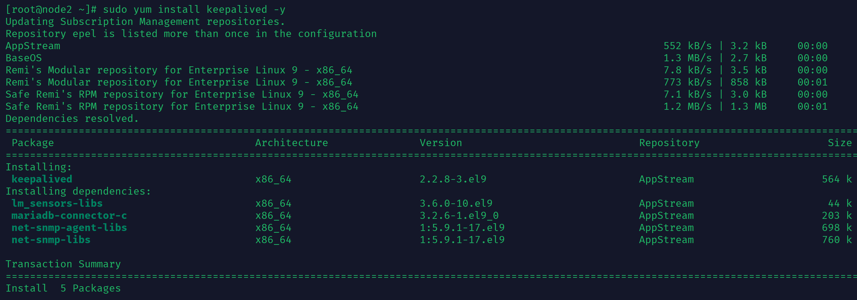

vim /etc/keepalived/keepalived.conf

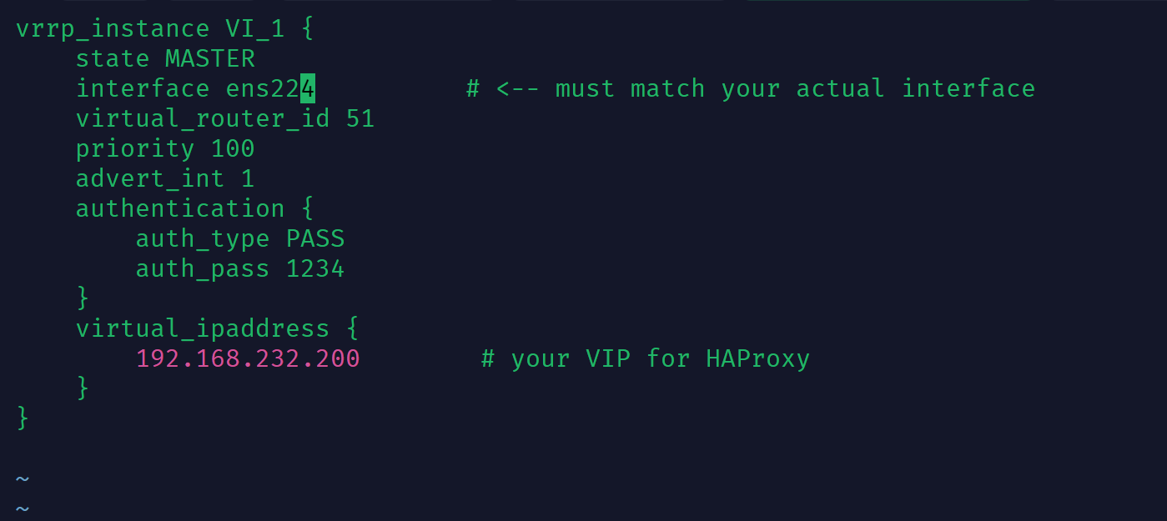

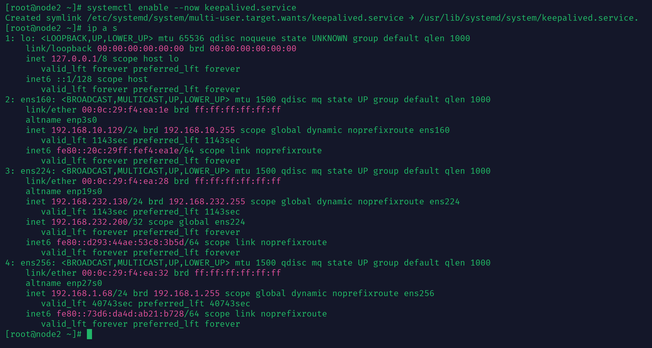

Node1

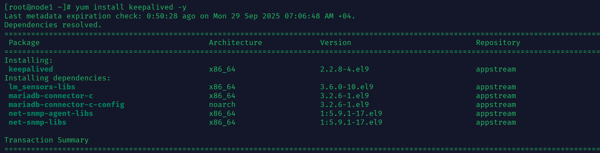

vim /etc/keepalived/keepalived.conf

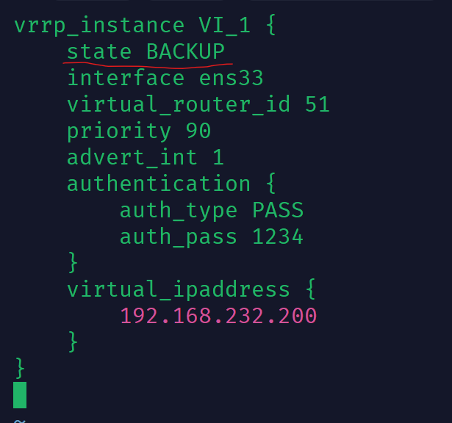

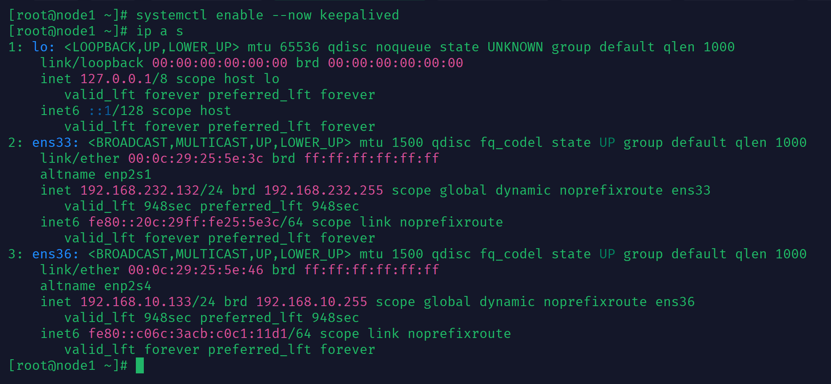

Don’t show IP address because this node backup

13.2 if one of the servers shuts down (or does not see each other on the network), the

virtual ip must switch to another

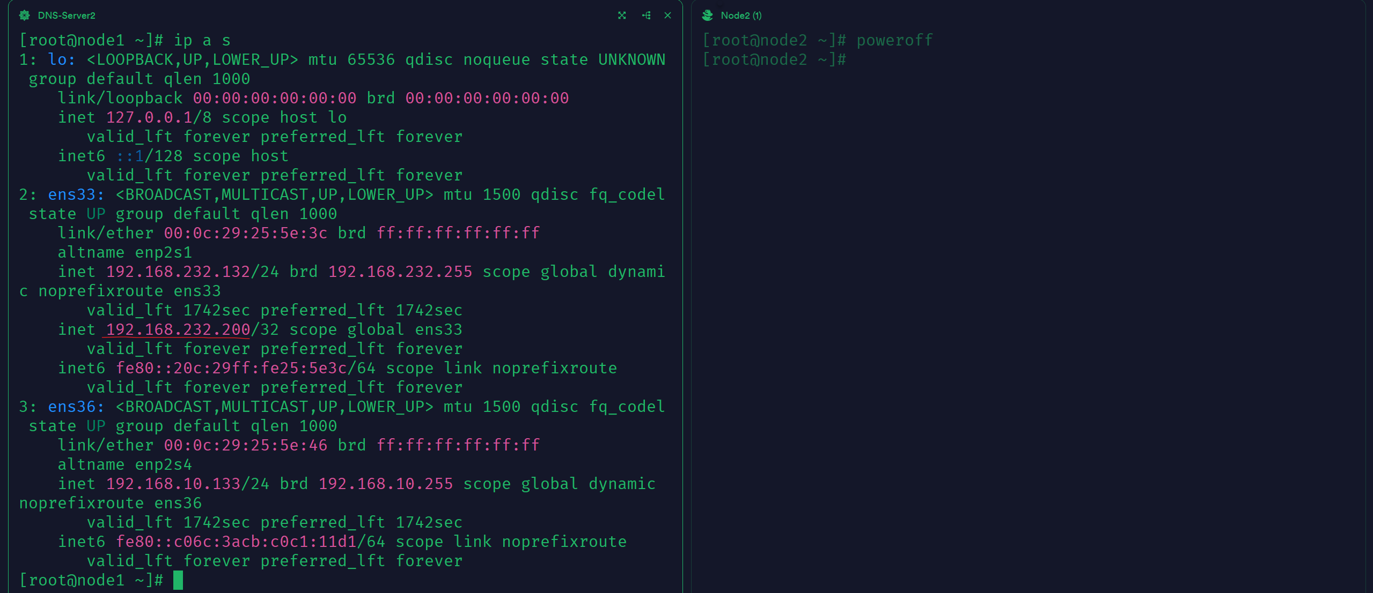



13.3 Load balance with new ip virtual address

